© 2019 Little Owls Resources



www.littleowls-premium.com *EDITABLE Resource*

English/French

**Animal Cards**

www.littleowls-premium.com © 2019 Little Owls Resources

www.littleowls-premium.com © 2019 Little Owls Resources

English/French

elephant

l'éléphant (lele-fon)

English/French

lion

lion

(lee-on)

English/French

tiger

tigre

(tee-gr)

www.littleowls-premium.com © 2019 Little Owls Resources

English/French

giraffe

girafe

(jee-raff)

English/French

penguin

manchot

(morn-show)

English/French

chimpanzee

chimpanzé (sharmp-arn-zee)

English/French

flamingo

flamant

(flam-on)

English/French

komodo dragon

dragon de komodo

(dragohn dur ko-mo-do)

English/French

sea lion

lion de mer

(lee-on dur m-air)

English/French

rhinoceros

rhinocéros

(ree-nor-sair-oss)

English/French

frog

grenouille

(gren-wee)

English/French

wolf

loup

(loo)

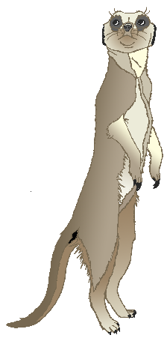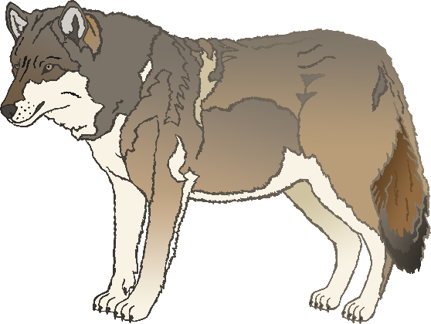

English/French

cow

vache

(vash)

English/French

meerkat

suricate

(suh-ree-cat)

English/French

zebra

zèbre

(zairb-r)

English/French

horse

cheval

(shur-val)

English/French

pig

porc

(por)

English/French

goat

chèvre

(sh-airv-r)

English/French

donkey

âne

(ann)

English/French

dog

chien

(shyan)

English/French

duck

canard

(can-arr)

English/French

goose

oie

(wuh)

English/French

sheep

mouton

(moo-ton)

English/French

chicken

poulet

(poo-lay)

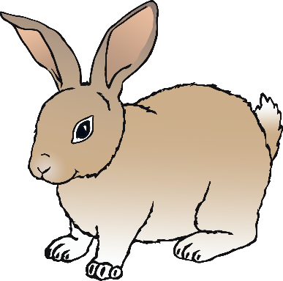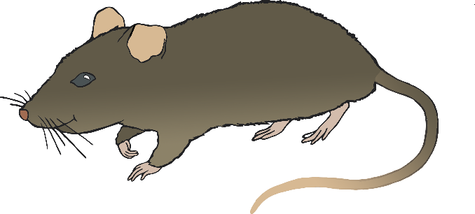

English/French

bird

oiseau

(wa-zoh)

English/French

rabbit

lapin

(la-pun)

English/French

rat

rat

(rah)

English/French

ox

bœuf

(burf)

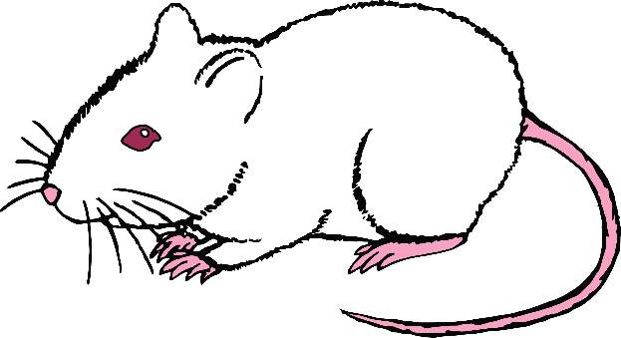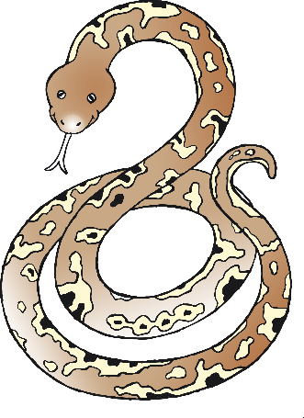

English/French

cat

chat

(shah)

English/French

mouse

souris

(soo-ree)

English/French

snake

serpent

(sair-pon)

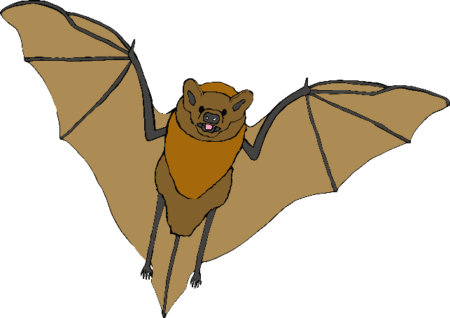

English/French

bat

chauve souris

(sh-ohv-soo-ree)

English/French

squirrel

écureuil

(ay-cyur-oy)

English/French

fox

renard

(ruh-nar)

English/French

hedgehog

hérisson

(eh-risson)

