© 2019 Little Owls Resources



www.littleowls-premium.com *EDITABLE Resource*

English/Chinese - Mandarin

English/Chinese-Mandarin

elephant

象

(sh-yun)

www.littleowls-premium.com © 2019 Little Owls Resources

www.littleowls-premium.com © 2019 Little Owls Resources

www.littleowls-premium.com © 2019 Little Owls Resources

English/Chinese-Mandarin

lion

獅

(shee)

English/Chinese-Mandarin

tiger

虎

(hoo)

**Animal Cards**

English/Chinese-Mandarin

giraffe

長頸鹿

(chung-sing-loo)

English/Chinese-Mandarin

flamingo

火烈鳥

(wuh-ling-n-ou)

English/Chinese-Mandarin

penguin

企鵝

(chee-oo-uh)

English/Chinese-Mandarin

chimpanzee

黑猩猩

(cree-sing-sing)

English/Chinese-Mandarin

komodo dragon

科莫多巨蜥

(ko-moh-doh joo-shee)

English/Chinese-Mandarin

sea lion

海獅

(h-eye-sh-ur)

English/Chinese-Mandarin

rhinoceros

犀牛

(shin-ee-oh)

English/Chinese-Mandarin

frog

青蛙

(sh-ing w-arr)

English/Chinese-Mandarin

wolf

狼

(lung)

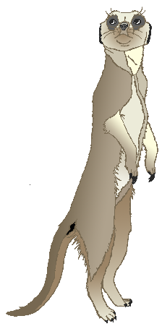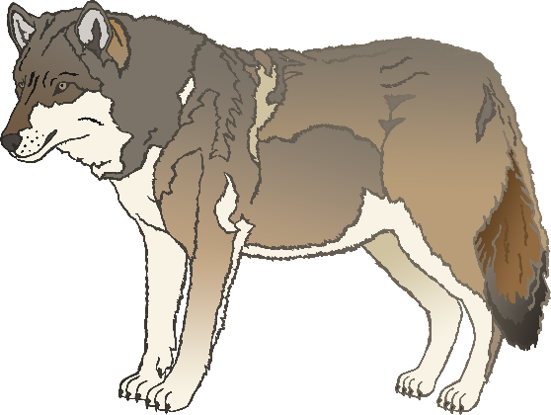

English/Chinese-Mandarin

cow

牛

(nee-y-oa)

English/Chinese-Mandarin

meerkat

貓鼬

(m-ou y-oa)

English/Chinese-Mandarin

zebra

斑馬

(pen-m-arr)

English/Chinese-Mandarin

horse

馬

(marr)

English/Chinese-Mandarin

pig

豬

(jz-oo)

English/Chinese-Mandarin

goat

山羊

(sh-ang-y-ang)

English/Chinese-Mandarin

donkey

驢

(loo)

English/Chinese-Mandarin

dog

狗

(g-oh)

English/Chinese-Mandarin

duck

鴨

(yarr)

English/Chinese-Mandarin

goose

鵝

(oo-uh)

English/Chinese-Mandarin

sheep

羊

(yang)

English/Chinese-Mandarin

chicken

雞

(chee)

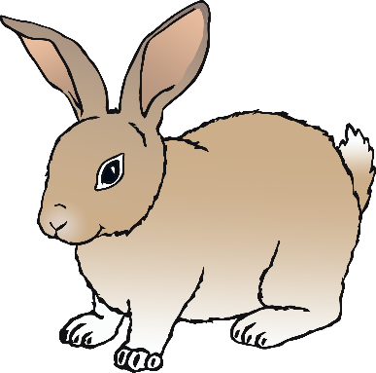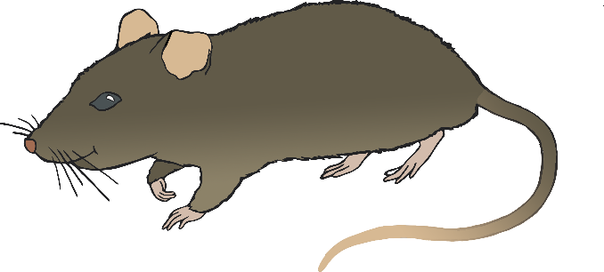

English/Chinese-Mandarin

bird

鳥

(nee-y-ou)

English/Chinese-Mandarin

rabbit

兔子

(toot-suh)

English/Chinese-Mandarin

rat

鼠

(shoo)

English/Chinese-Mandarin

ox

犉

(roo-en)

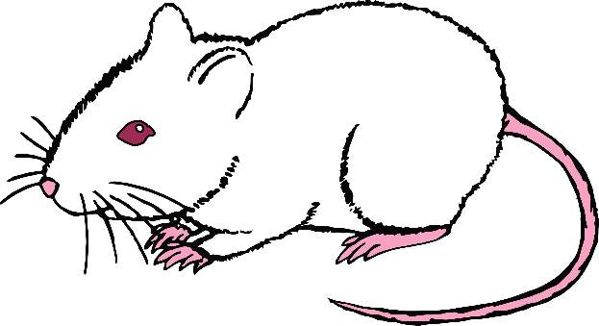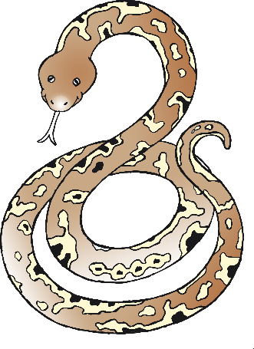

English/Chinese-Mandarin

cat

貓

(m-ou)

English/Chinese-Mandarin

mouse

老鼠

(l-ou-shoo)

English/Chinese-Mandarin

snake

蛇

(sh-yur)

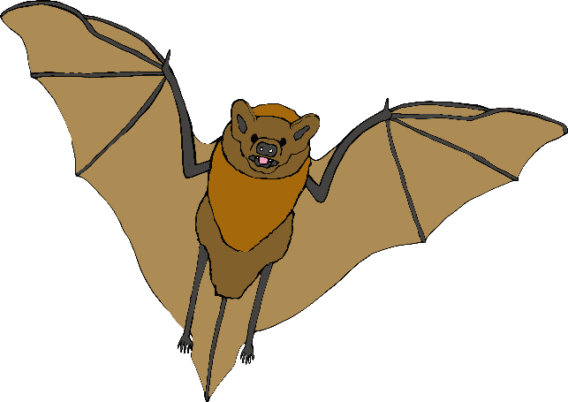

English/Chinese-Mandarin

bat

蝙蝠

(bee-en-foo)

English/Chinese-Mandarin

squirrel

松鼠

(song-shoo)

English/Chinese-Mandarin

fox

狐狸

(hoo-lee)

English/Chinese-Mandarin

hedgehog

猬

(w-ay)

