© 2019 Little Owls Resources



www.littleowls-premium.com *EDITABLE Resource*

English/Bengali

www.littleowls-premium.com © 2019 Little Owls Resources

www.littleowls-premium.com © 2019 Little Owls Resources

www.littleowls-premium.com © 2019 Little Owls Resources

English/Bengali

elephant

হাতি

(hut-ee)

English/Bengali

lion

সিংহ

(sin-hoh)

English/Bengali

tiger

বাঘ

(barg)

**Animal Cards**

English/Bengali

giraffe

জিরাফ

(ji-raff)

English/Bengali

penguin

পেংগুইন

(pen-goon)

English/Bengali

chimpanzee

শিম্পাঞ্জি

(chim-pan-zee)

English/Bengali

flamingo

মরাল

(moh-rol)

English/Bengali

komodo dragon

কোমোডো ড্রাগন

(ko-moh-doh drag-on)

English/Bengali

sea lion

সমুদ্র সিংহ

(sha-moodra-sin-hoh)

English/Bengali

rhinoceros

গণ্ডার

(gond-uh)

English/Bengali

frog

বেঙ

(ban)

English/Bengali

wolf

নেকড়ে

(nek-reh)

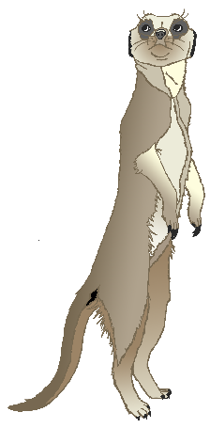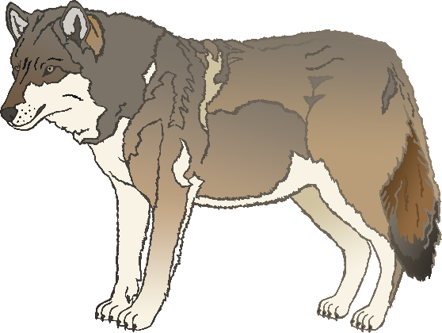

English/Bengali

cow

গাভী

(gub-ee)

English/Bengali

meerkat

মিরক্যাট

(meera-cat)

English/Bengali

zebra

জেব্রা

(jeb-rah)

English/Bengali

horse

ঘোড়া

(g-hor-uh)

English/Bengali

pig

শূকর

(shoo-koor)

English/Bengali

goat

ছাগল

(chag-ool)

English/Bengali

donkey

গাধা

(gad-ha)

English/Bengali

dog

কুকুর

(koo-koor)

English/Bengali

duck

হাঁস

(hush)

English/Bengali

goose

হংসী

(hun-see)

English/Bengali

sheep

ভেড়া

(v-air-ah)

English/Bengali

chicken

মুরগির

(moor-gee)

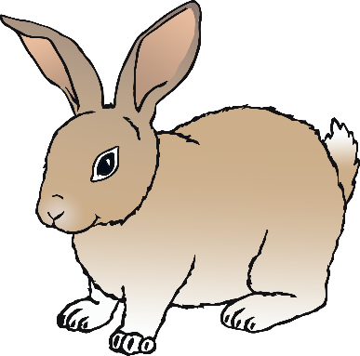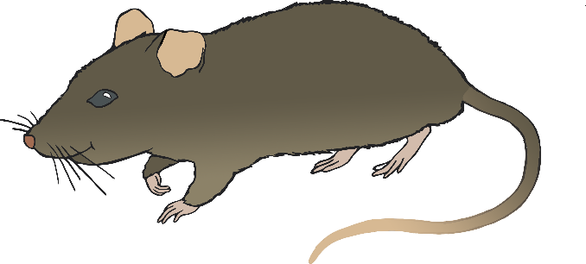

English/Bengali

bird

পাখি

(pa-kee)

English/Bengali

rabbit

খরগোশ

(horr-goosh)

English/Bengali

rat

ইঁদুর

(ih-door)

English/Bengali

ox

গোরু

(goh-roo)

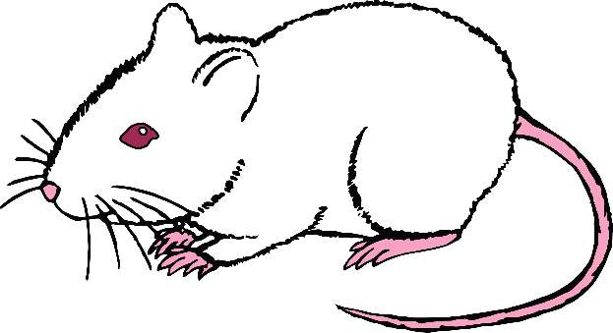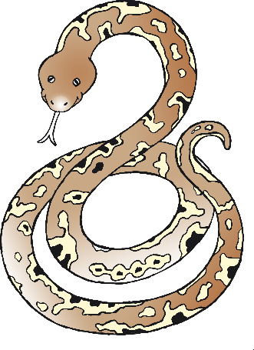

English/Bengali

cat

বিড়াল

(bih-ral)

English/Bengali

mouse

মাউস

(m-ou-ss)

English/Bengali

snake

সাপ

(shup)

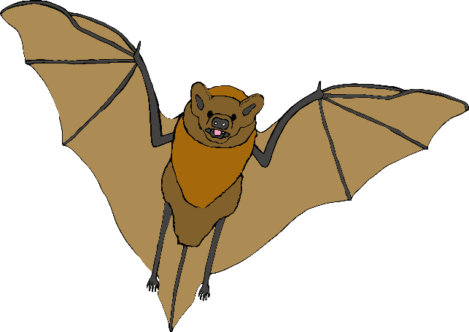

English/Bengali

bat

বাদুড়

(bud-oor)

English/Bengali

squirrel

কাঠবিড়াল (kath-bih-rul)

English/Bengali

fox

শিয়াল

(shee-ull)

English/Bengali

hedgehog

কাঁটাচয়া

(cut-et-seh)

