© 2019 Little Owls Resources



www.littleowls-premium.com *EDITABLE Resource*

English/Arabic

www.littleowls-premium.com © 2019 Little Owls Resources

www.littleowls-premium.com © 2019 Little Owls Resources

www.littleowls-premium.com © 2019 Little Owls Resources

English/Arabic

elephant

فيل

(feel)

English/Arabic

lion

أسد

(assad)

English/Arabic

tiger

نمر

(namir)

)

**Animal Cards**

English/Arabic

giraffe

زرافة

(za-rarffa)

English/Arabic

penguin

بِطْريق

(but-reerk)

English/Arabic

chimpanzee

شَمْبَنْزي

(sham-ban-zee)

English/Arabic

flamingo

بَشاروش

(basha-roosh)

English/Arabic

komodo dragon

تنين كومودو

(tun-in oh ko-moh-doh)

English/Arabic

sea lion

أَسَد البَحْرِ

(assad el bahr)

English/Arabic

rhinoceros

كَرْكَدَنّ

(kurka-dan)

English/Arabic

frog

ضِفْدَع

(diff-dah)

English/Arabic

wolf

ذِئْب

(dhib)

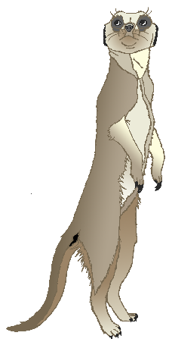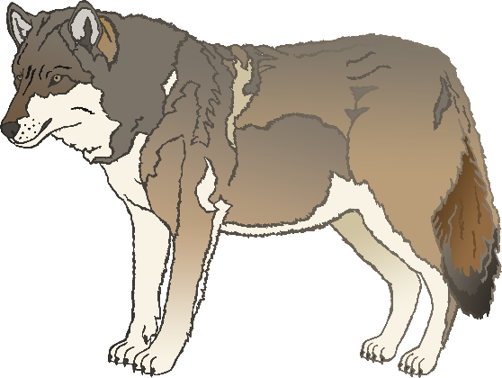

English/Arabic

cow

بقرة

(ba-kara)

English/Arabic

meerkat

الميركات

(al-m-eye-ro-kat-oh)

English/Arabic

zebra

الحمار الوحشي

(al-hamar al-wah-shee-yoo)

English/Arabic

horse

حصان

(hiss-ahn)

English/Arabic

pig

خِنْزير

(kin-zeer)

English/Arabic

goat

ماعز

(marz)

English/Arabic

donkey

حمار

(hih-mar)

English/Arabic

dog

كَلَب

(kalub)

English/Arabic

duck

بَطّة

(batta)

English/Arabic

goose

إوَزّ

(ih-waz)

English/Arabic

sheep

خَروف

(kar-oof)

English/Arabic

chicken

دجاج

(da-zjar-jah)

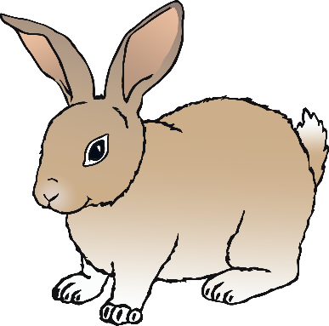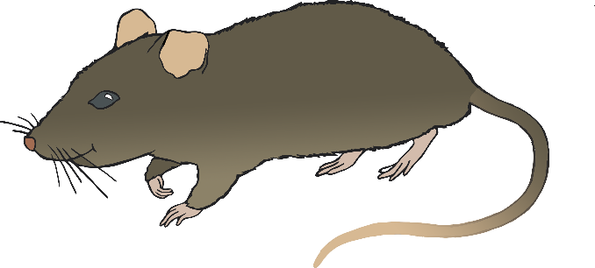

English/Arabic

bird

طَيْر

(t-eye-r)

English/Arabic

rabbit

أرنب

(arnab)

English/Arabic

rat

جُرَذ

(joor-ev)

English/Arabic

ox

ثَوْر

(thou-wer)

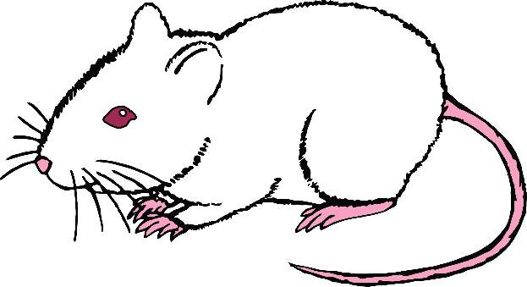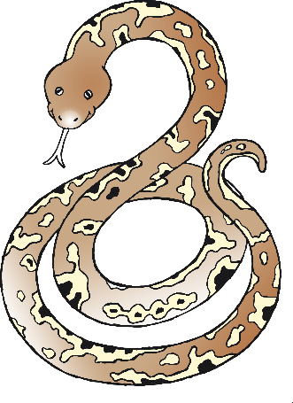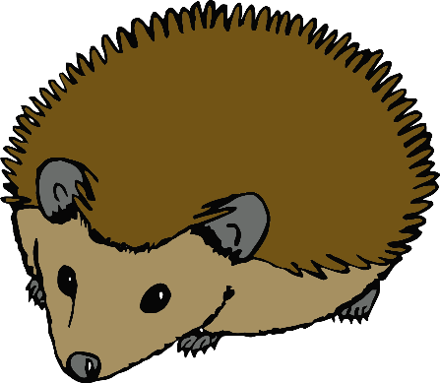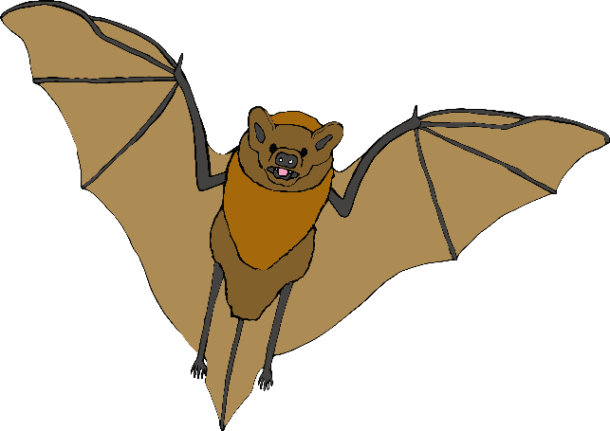

English/Arabic

cat

قط

(kit)

English/Arabic

mouse

فأر

(fa-ar)

English/Arabic

snake

ثُعْبان

(tho-ban)

English/Arabic

bat

خفاش

(ho-fash)

English/Arabic

squirrel

سِنْجاب

(sin-jab)

English/Arabic

fox

ثَعْلَب

(thar-lub)

English/Arabic

hedgehog

قُنْفُذ

(kun-footh)