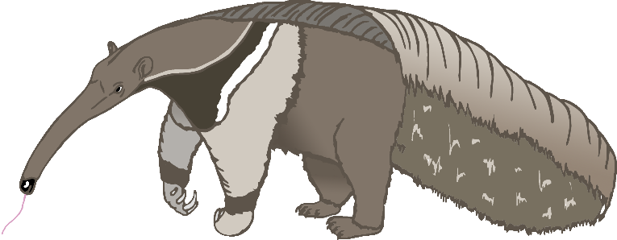

A

anteater

B

bat

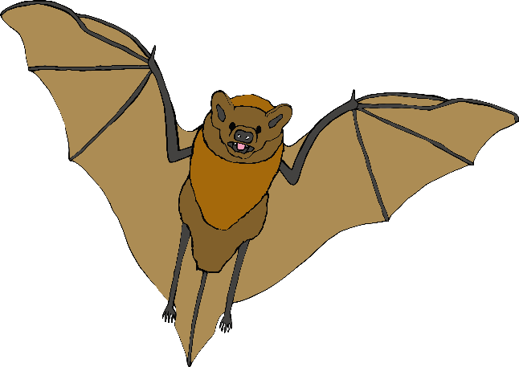

C

cow

D

dog

E

elephant

F

frog

G

goat

H

horse

I

iguana

J

jellyfish

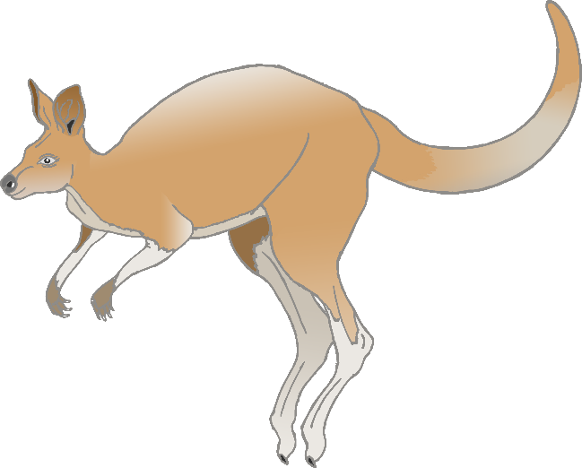

K

kangaroo

L

lion

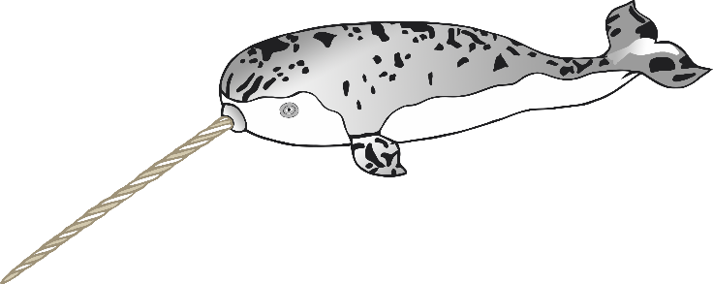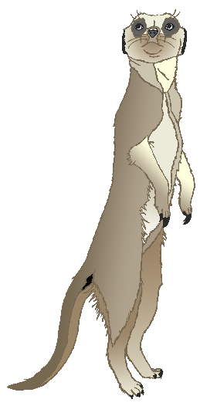

M

meerkat

N

narwhal

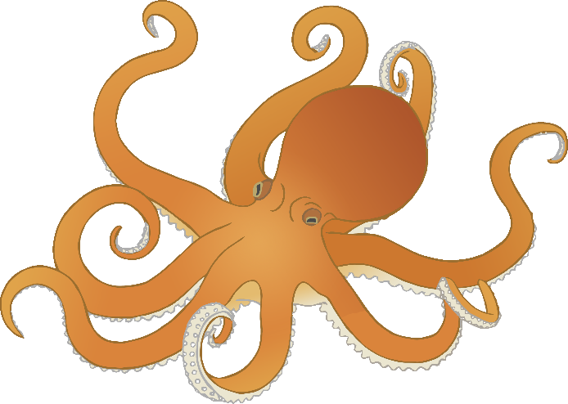

O

octopus

P

pig

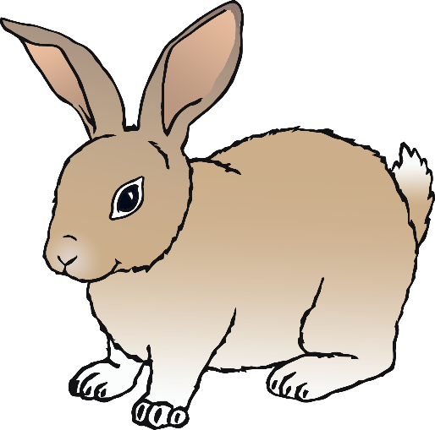

**Q**

quail

R

rabbit

S

squirrel

T

tiger

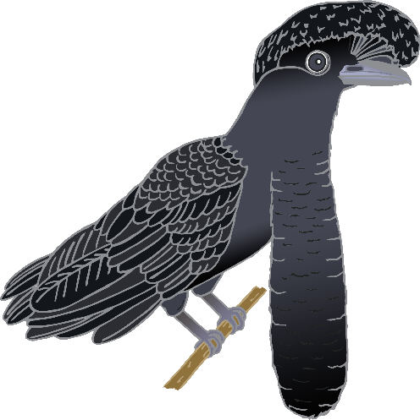

U

umbrella bird

V

vulture

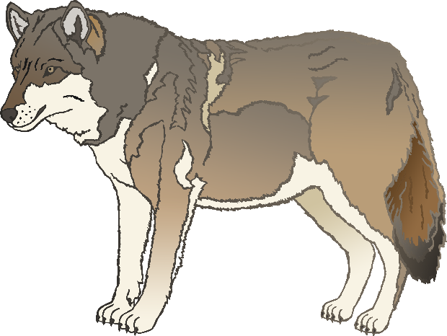

W

wolf

X

fox

Y

yak

Z

zebra