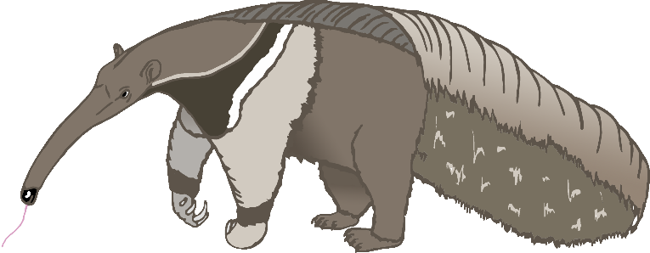

Aa

anteater

Bb

bat

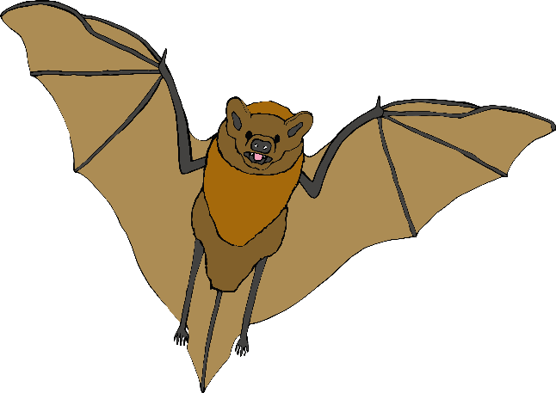

Cc

cow

Dd

dog

Ee

elephant

Ff

frog

Gg

goat

Hh

horse

Ii

iguana

Jj

jellyfish

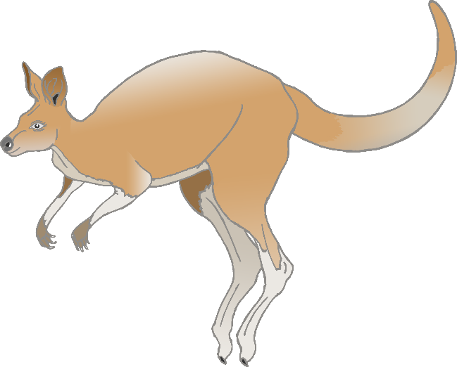

Kk

kangaroo

Ll

lion

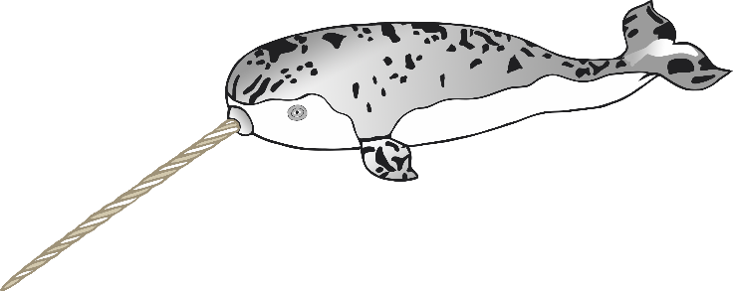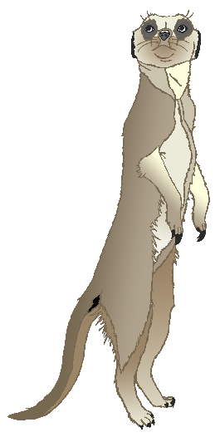

Mm

meerkat

Nn

narwhal

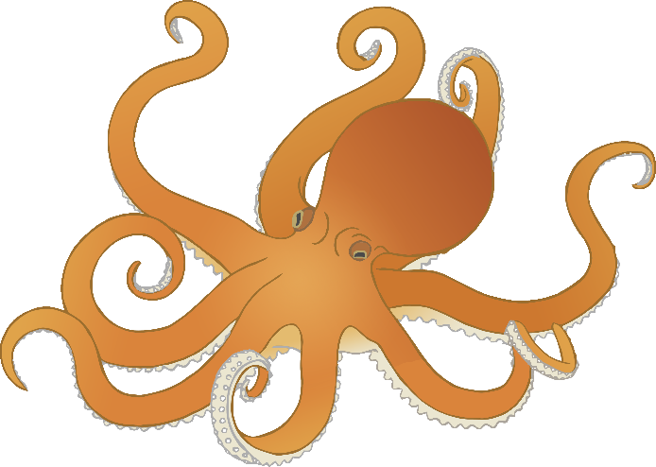

Oo

octopus

Pp

pig

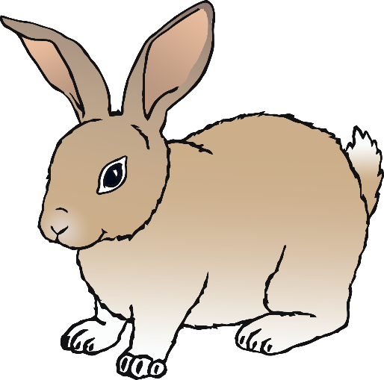

**Q**q

quail

Rr

rabbit

Ss

squirrel

Tt

tiger

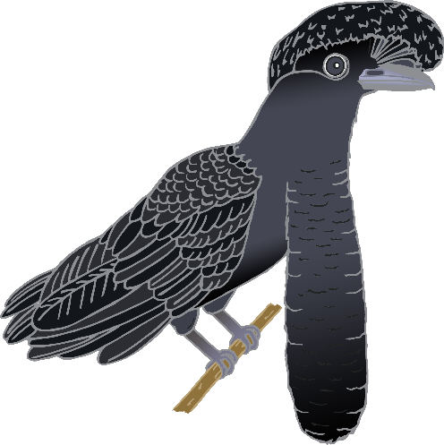

Uu

umbrella bird

Vv

vulture

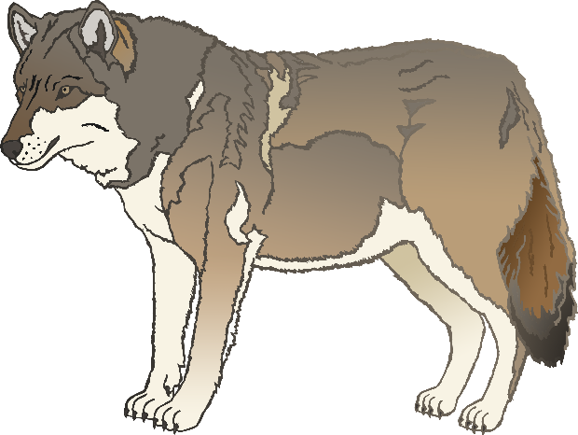

Ww

wolf

Xx

fox

Yy

yak

Zz

zebra