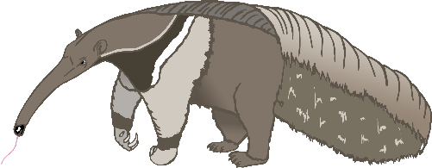

anteater

A

bat

B

cow

C

dog

D

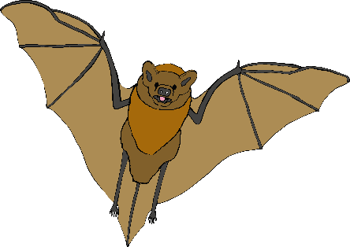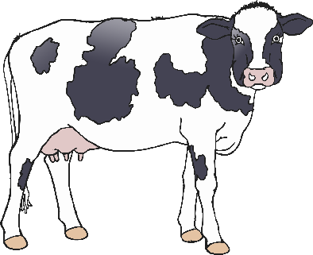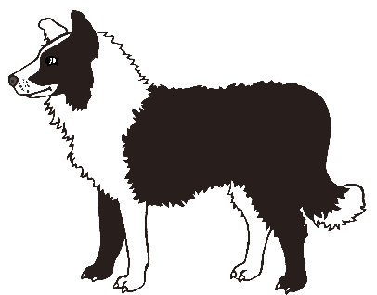

elephant

E

frog

F

goat

G

horse

H

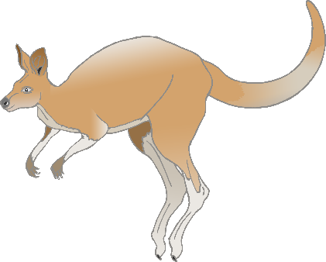

iguana

I

jellyfish

J

kangaroo

K

lion

L

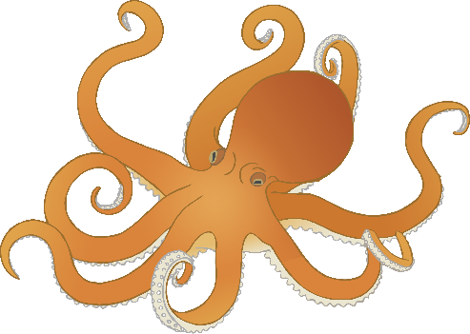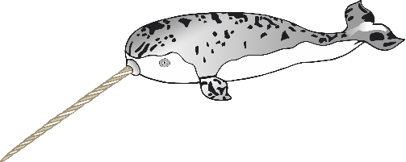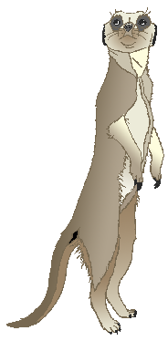

meerkat

M

narwhal

N

octopus

O

pig

P

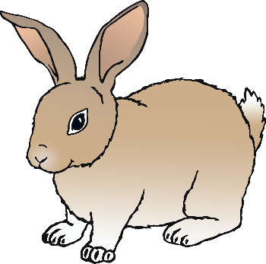

quail

**Q**

rabbit

R

squirrel

S

tiger

T

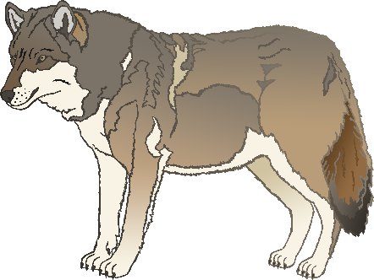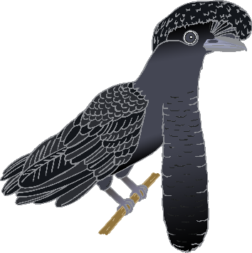

umbrella bird

U

vulture

V

wolf

W

fox

X

yak

Y

zebra

Z