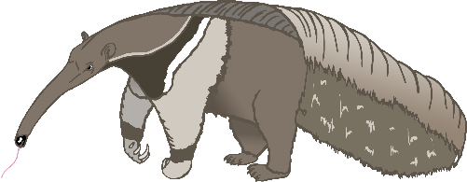

anteater

a

bat

b

cow

c

dog

d

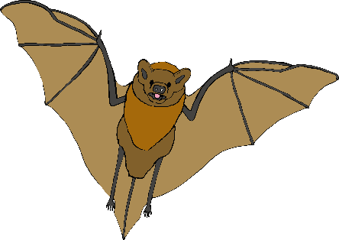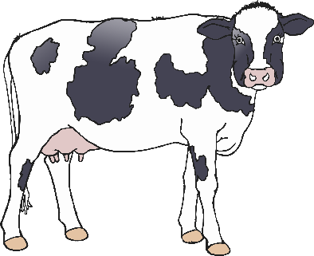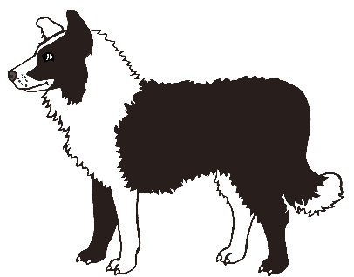

elephant

e

frog

f

goat

g

horse

h

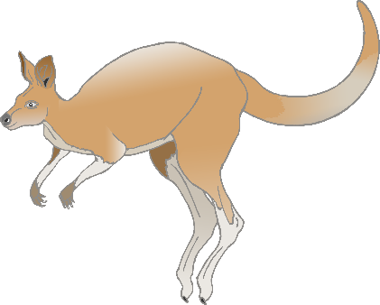

iguana

i

jellyfish

j

kangaroo

k

lion

l

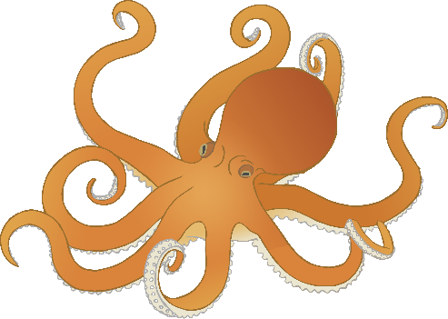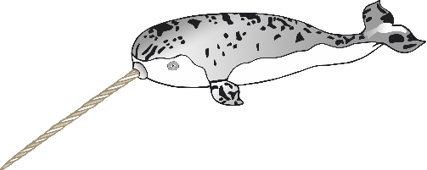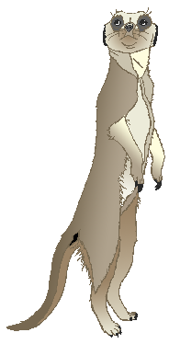

meerkat

m

narwhal

n

octopus

o

pig

p

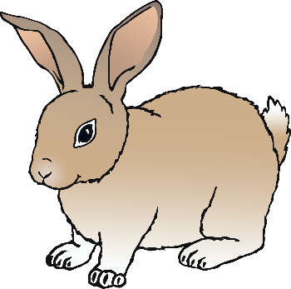

quail

q

rabbit

r

squirrel

s

tiger

t

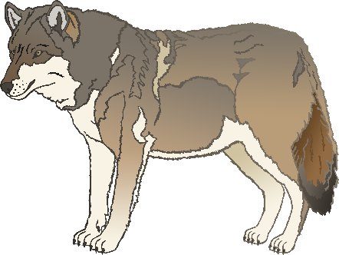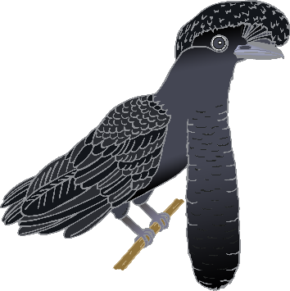

umbrella bird

u

vulture

v

wolf

w

fox

x

yak

y

zebra

z