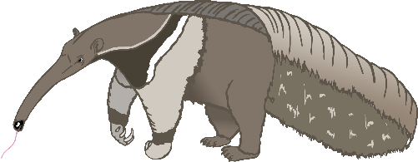

anteater

Aa

bat

Bb

cow

Cc

dog

Dd

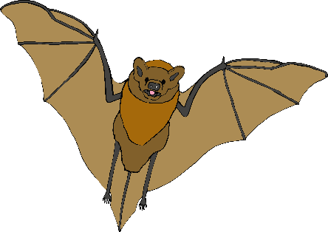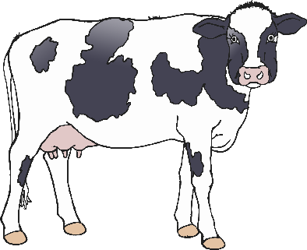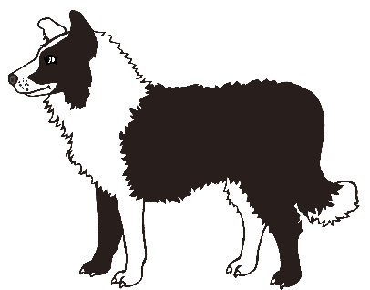

elephant

Ee

frog

Ff

goat

Gg

horse

Hh

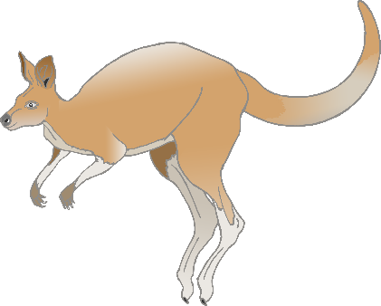

iguana

Ii

jellyfish

Jj

kangaroo

Kk

lion

Ll

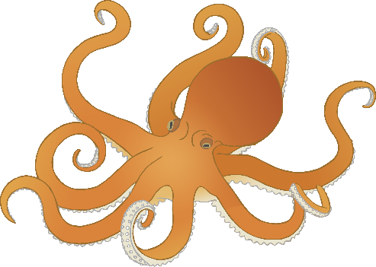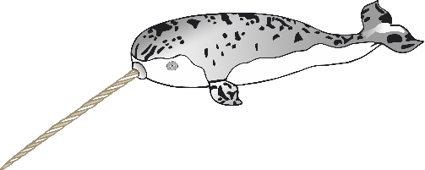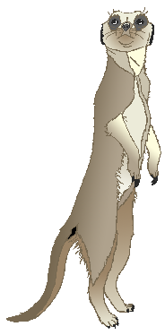

meerkat

Mm

narwhal

Nn

octopus

Oo

pig

Pp

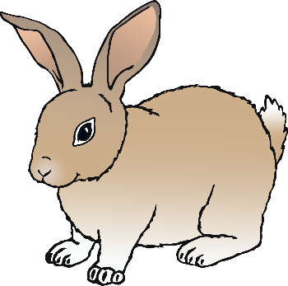

quail

**Q**q

rabbit

Rr

squirrel

Ss

tiger

Tt

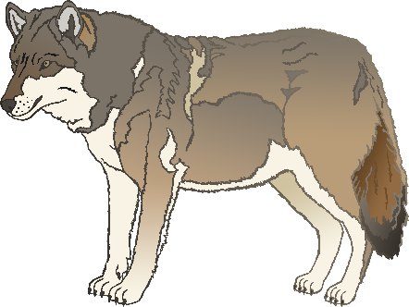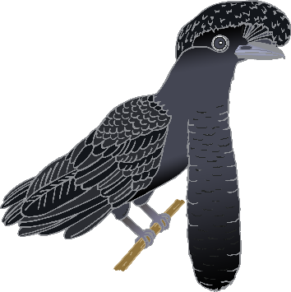

umbrella bird

Uu

vulture

Vv

wolf

Ww

fox

Xx

yak

Yy

zebra

Zz