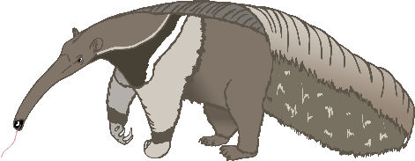

A

anteater

bat

B

cow

C

dog

D

elephant

E

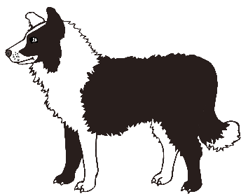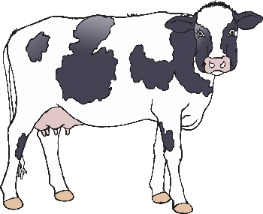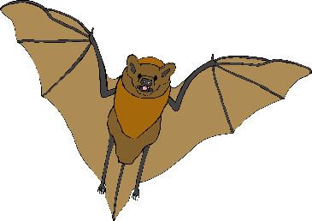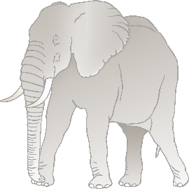

F

frog

goat

G

horse

H

iguana

I

jellyfish

J

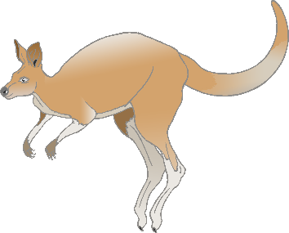

K

kangaroo

lion

L

meerkat

M

narwhal

N

octopus

O

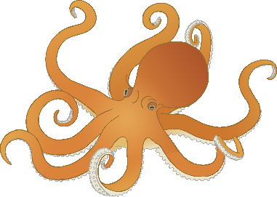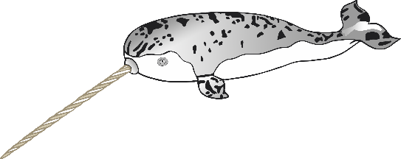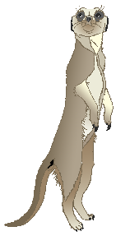

P

pig

quail

**Q**

rabbit

R

squirrel

S

tiger

T

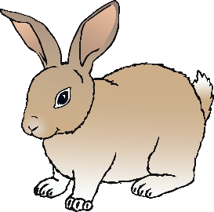

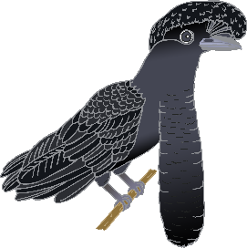

U

umbrella bird

vulture

V

wolf

W

fox

X

yak

Y

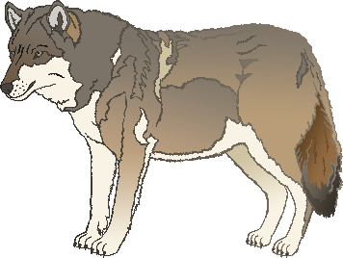

Z

zebra