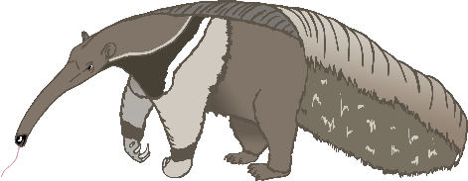

a

anteater

bat

b

cow

c

dog

d

elephant

e

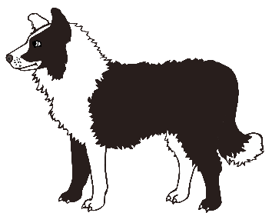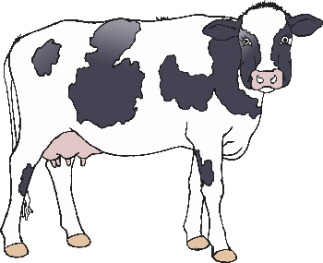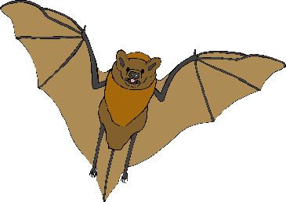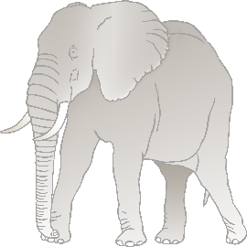

f

frog

goat

g

horse

h

iguana

i

jellyfish

j

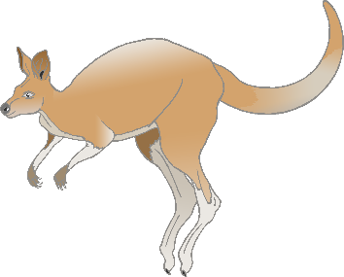

k

kangaroo

lion

l

meerkat

m

narwhal

n

octopus

o

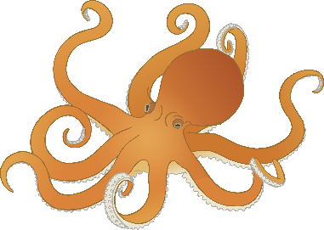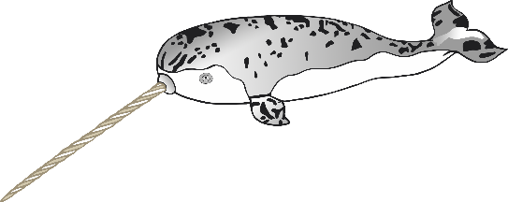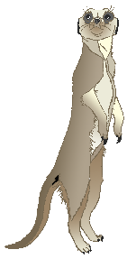

p

pig

quail

q

rabbit

r

squirrel

s

tiger

t

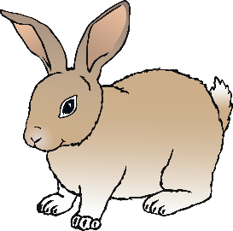

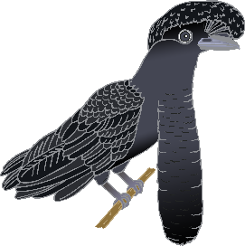

u

umbrella bird

vulture

v

wolf

w

fox

x

yak

y

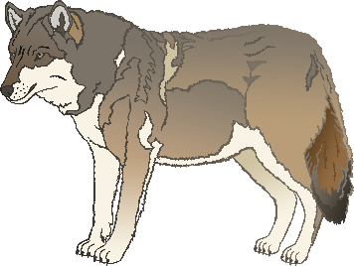

z

zebra