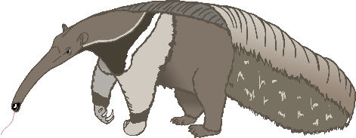

Aa

anteater

bat

Bb

cow

Cc

dog

Dd

elephant

Ee

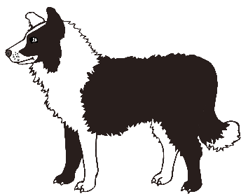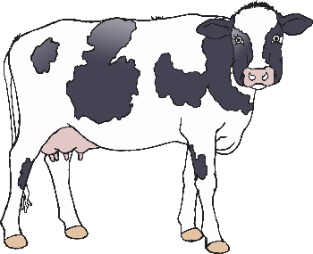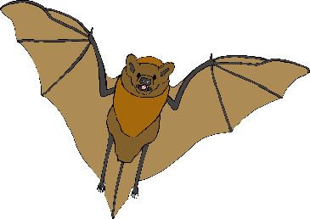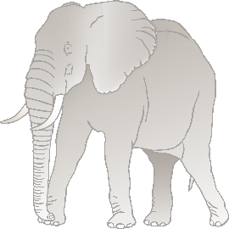

Ff

frog

goat

Gg

horse

Hh

iguana

Ii

jellyfish

Jj

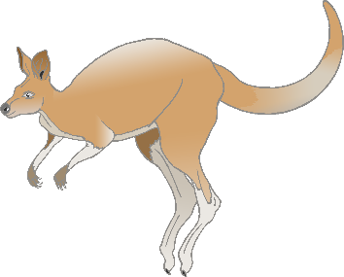

Kk

kangaroo

lion

Ll

meerkat

Mm

narwhal

Nn

octopus

Oo

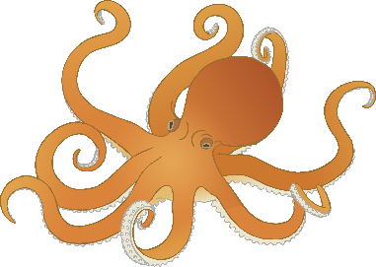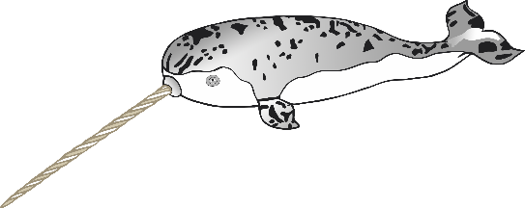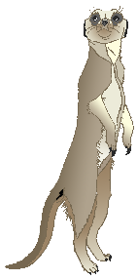

Pp

pig

quail

**Q**q

rabbit

Rr

squirrel

Ss

tiger

Tt

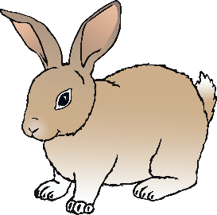

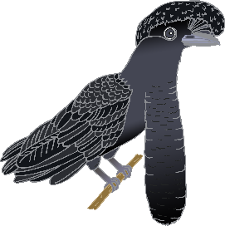

Uu

umbrella bird

vulture

Vv

wolf

Ww

fox

Xx

yak

Yy

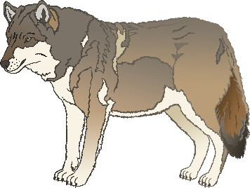

Zz

zebra