a

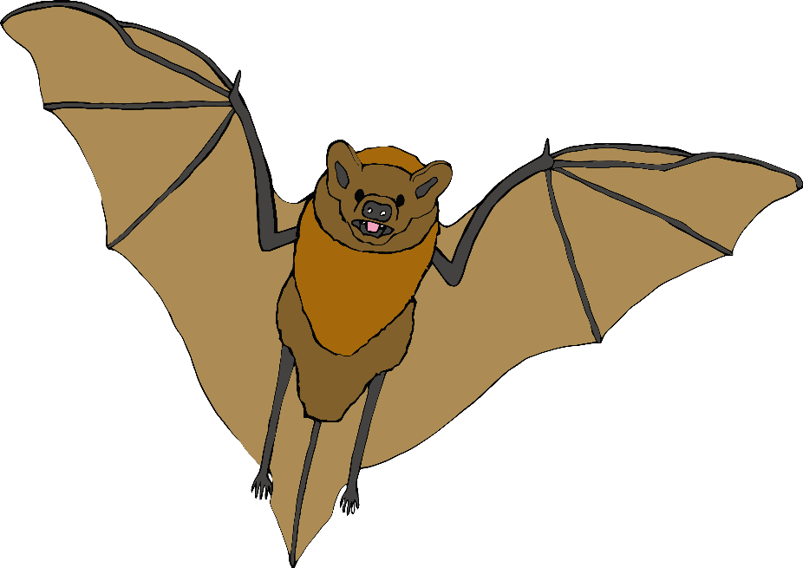

b

c

d

e

f

g

h

i

j

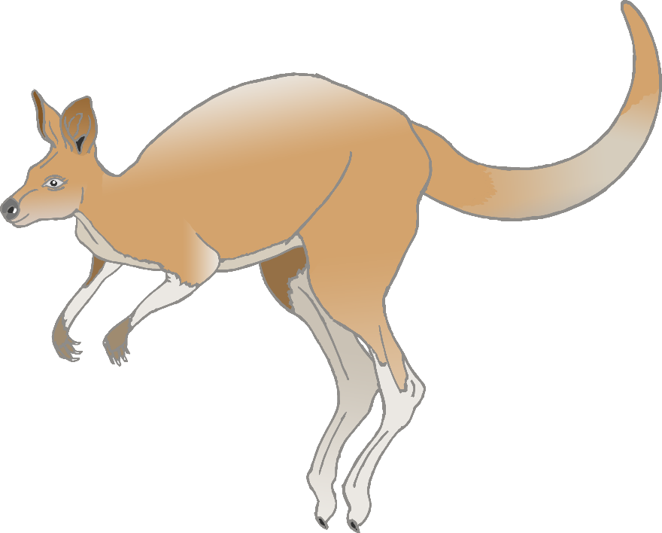

k

l

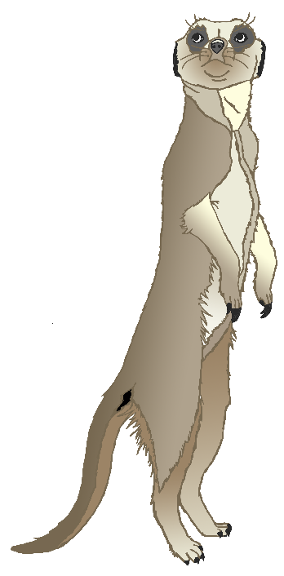

m

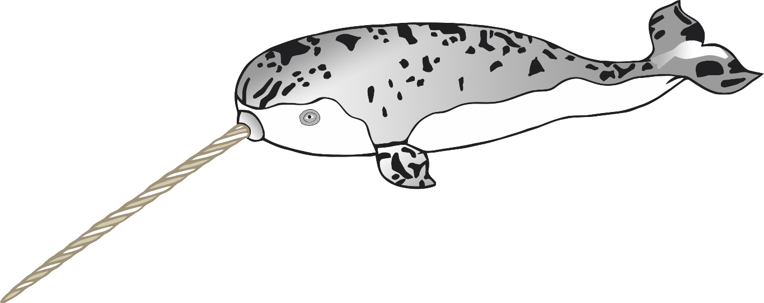

n

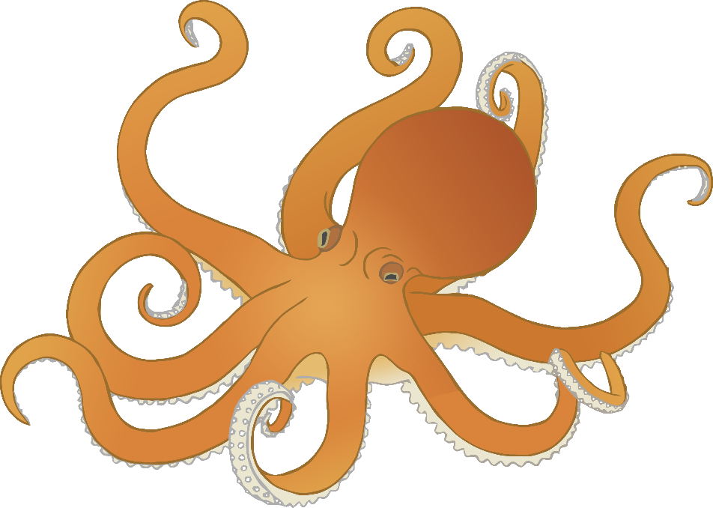

o

p

q

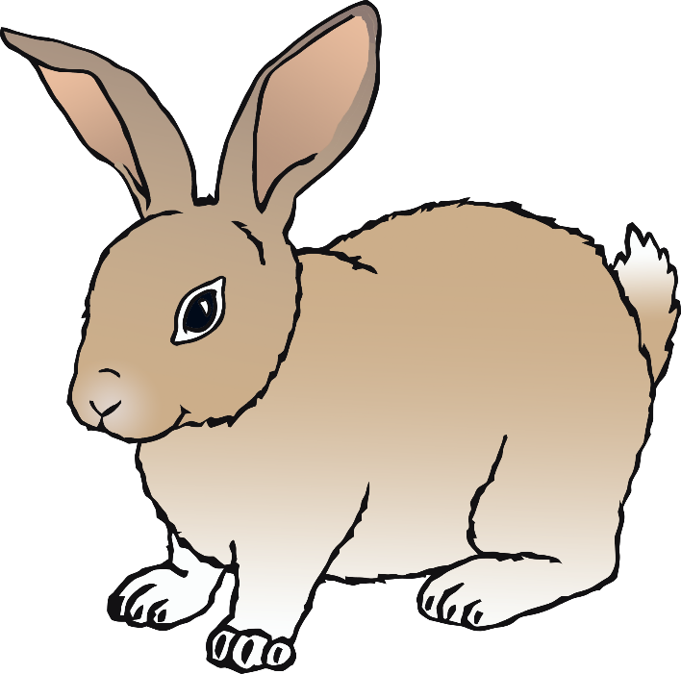

r

s

t

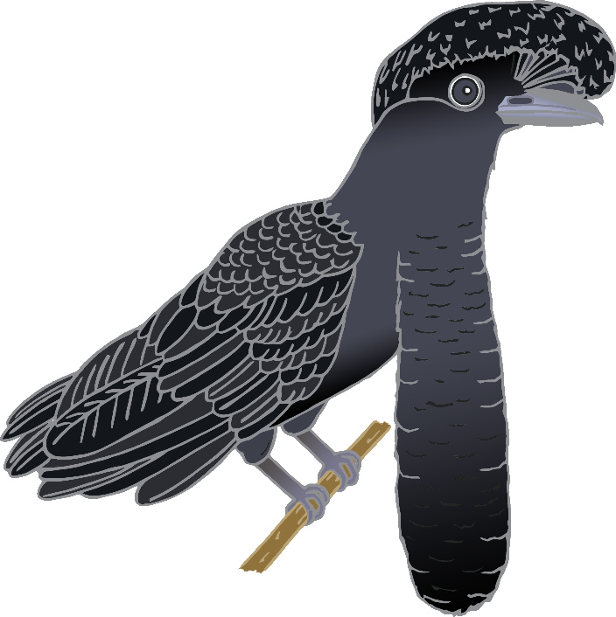

u

v

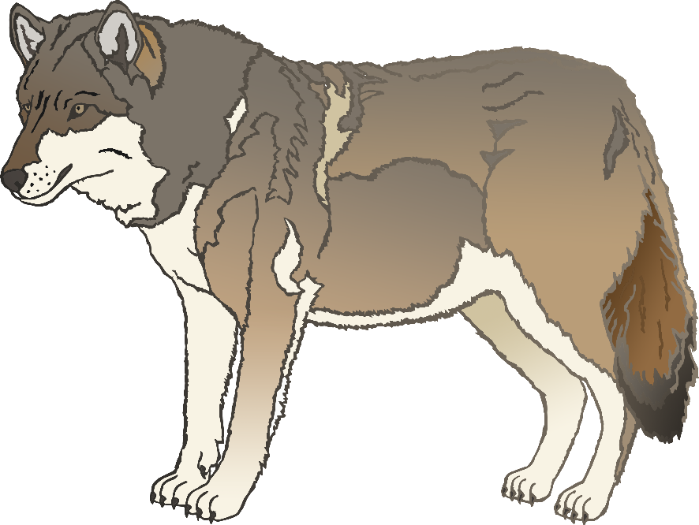

**w**

x

z

y