© 2020 Little Owls Resources

Animal Alphabet Multimats

These mats can be laminated and used as:

* Playdough mats
* Letter writing practice sheets
* Loose part activity sheets
* A large alphabet display

We hope it helps!

**a**

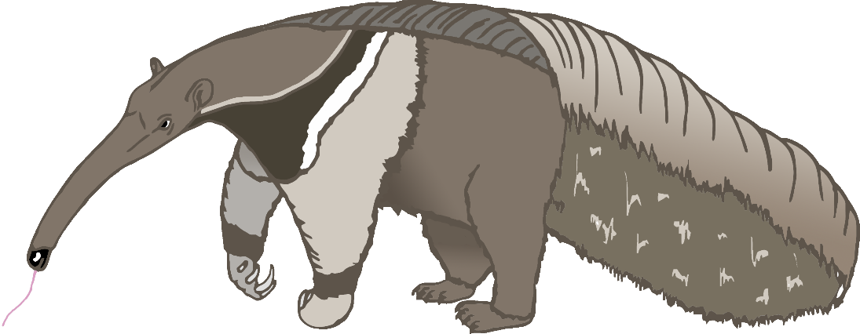

anteater

**b**

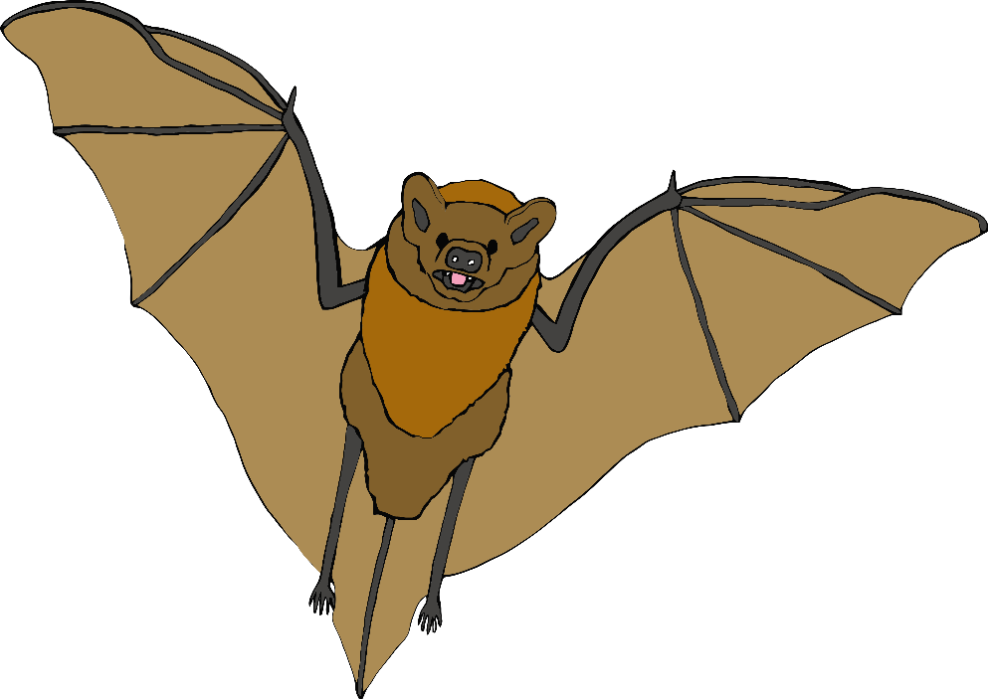

bat

**c**

cow

**d**

dog

**e**

elephant

**f**

frog

**g**

goat

**h**

horse

**i**

iguana

**j**

jellyfish

**k**

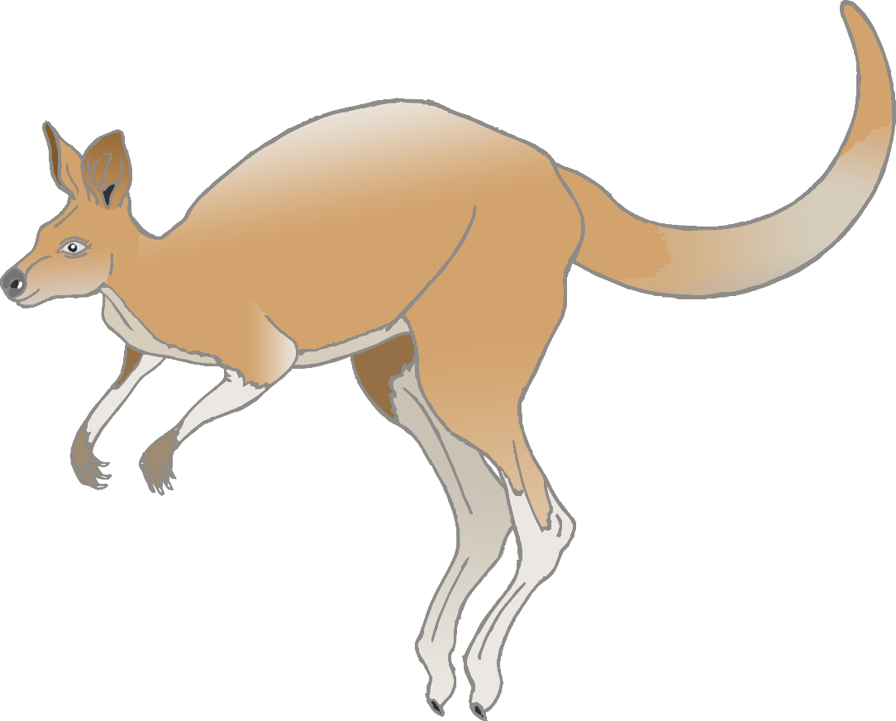

kangaroo

**l**

lion

**m**

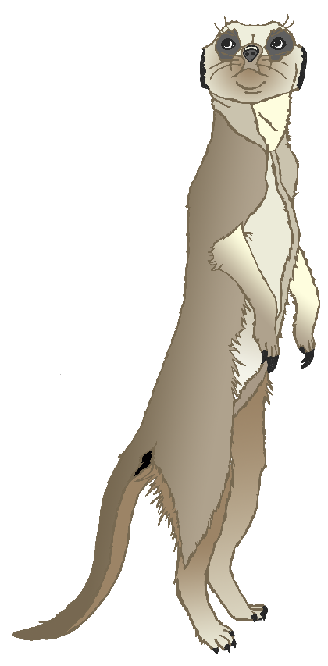

meerkat

**n**

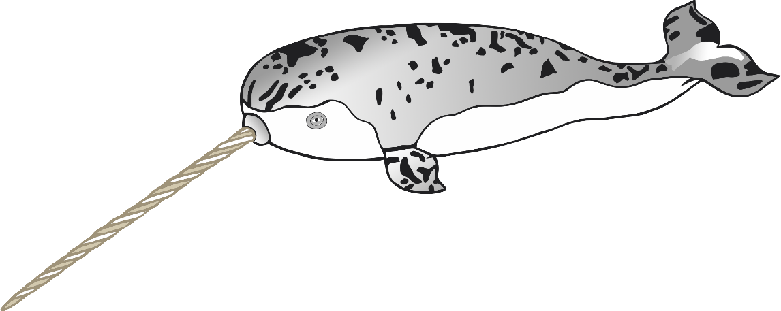

narwhal

**o**

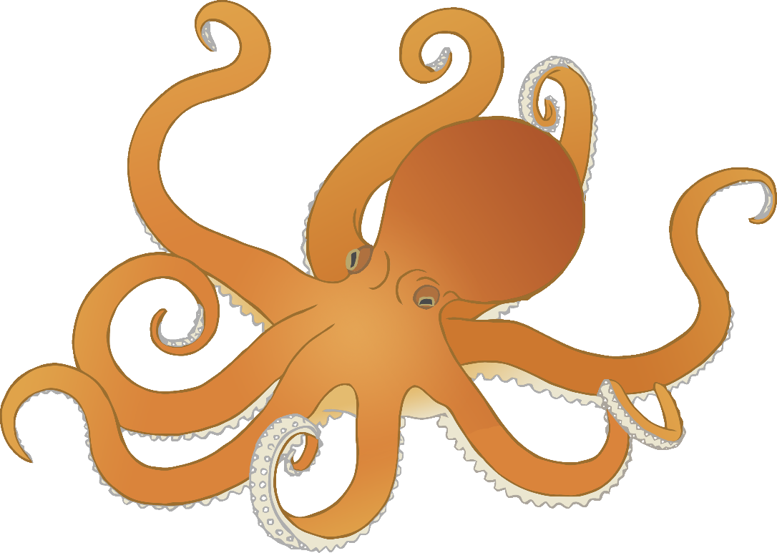

octopus

**p**

pig

**q**

quail

**r**

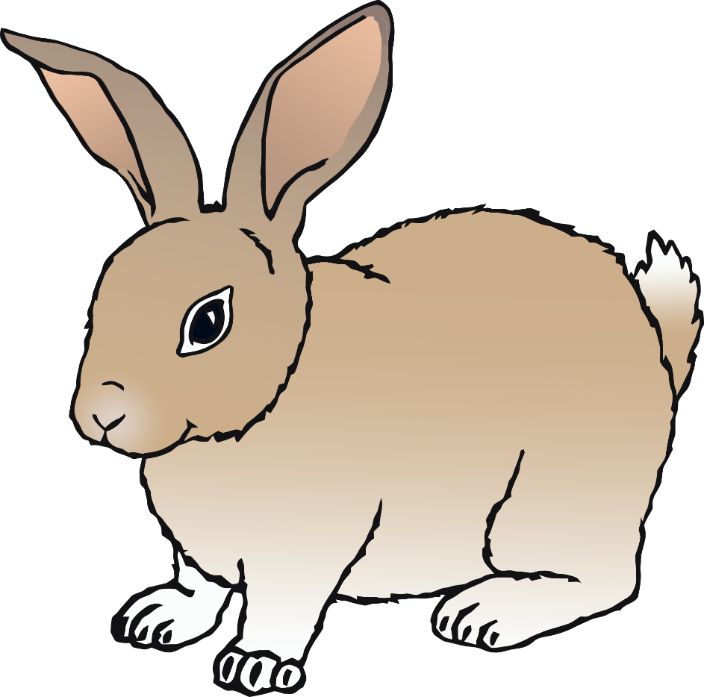

rabbit

**s**

squirrel

**t**

tiger

**u**

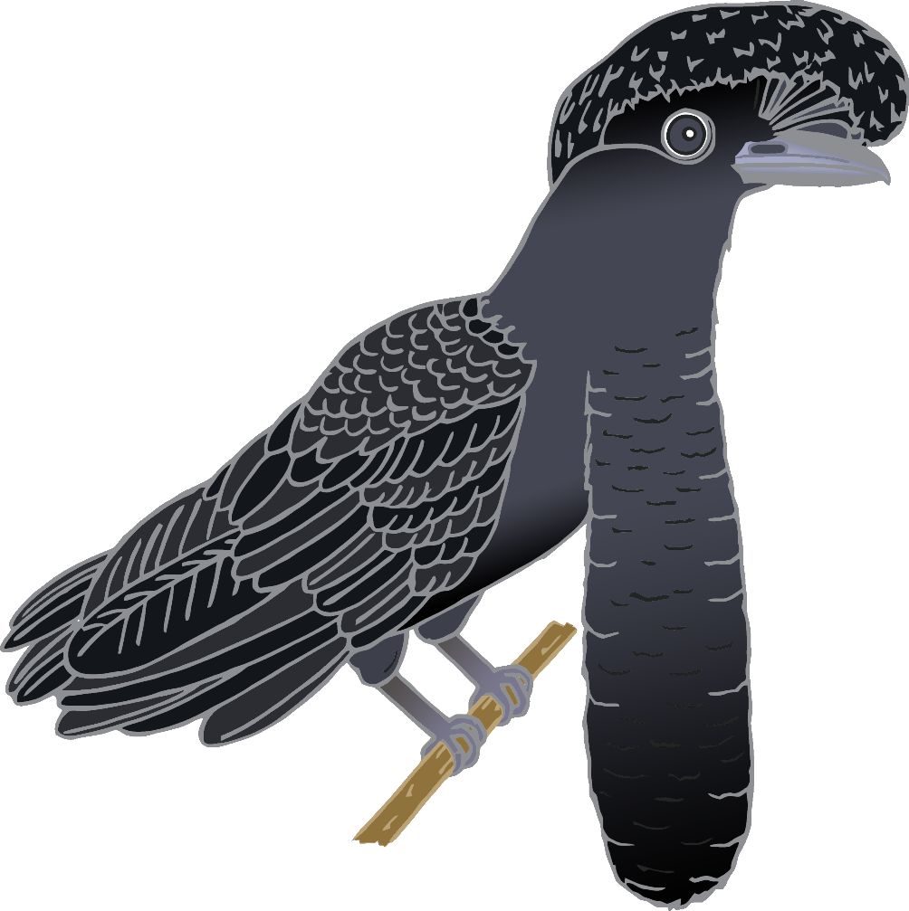

umbrella bird

**v**

vulture

**w**

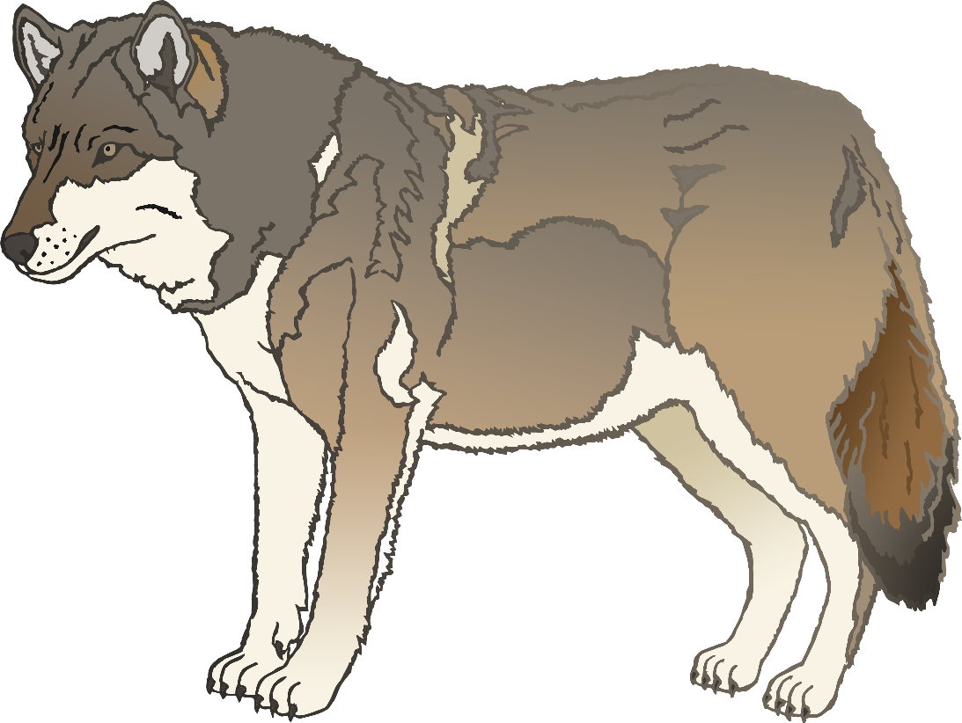

wolf

**x**

fox

**y**

yak

zebra

**z**