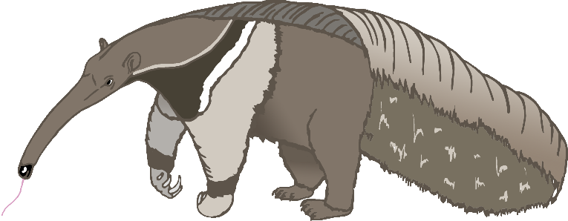

A

anteater

B

bat

C

cow

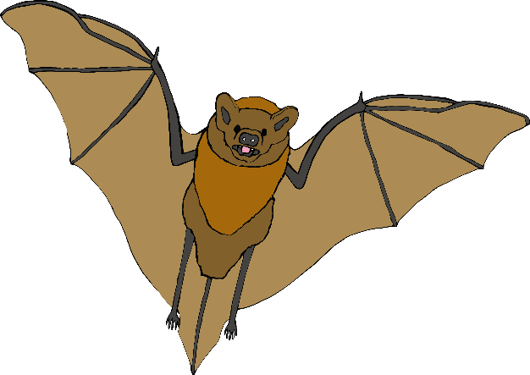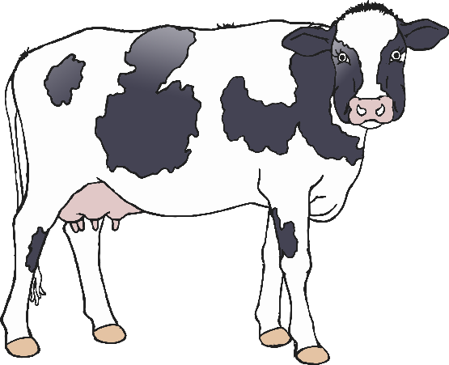

D

dog

E

elephant

F

frog

G

goat

H

horse

I

iguana

J

jellyfish

K

kangaroo

L

lion

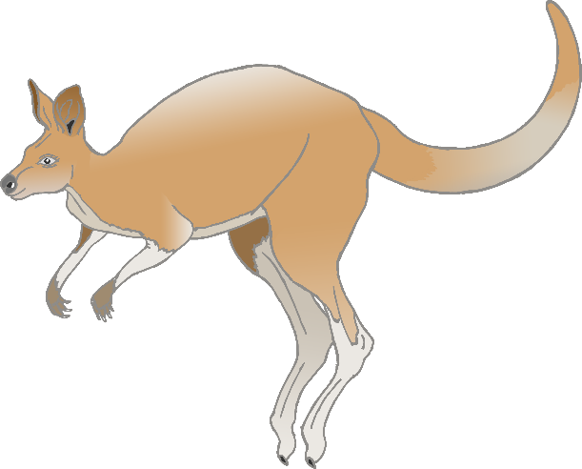

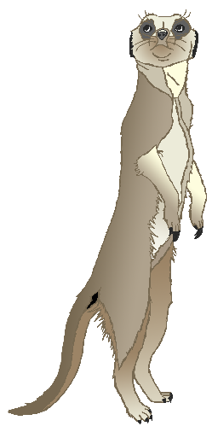

M

meerkat

N

narwhal

O

octopus

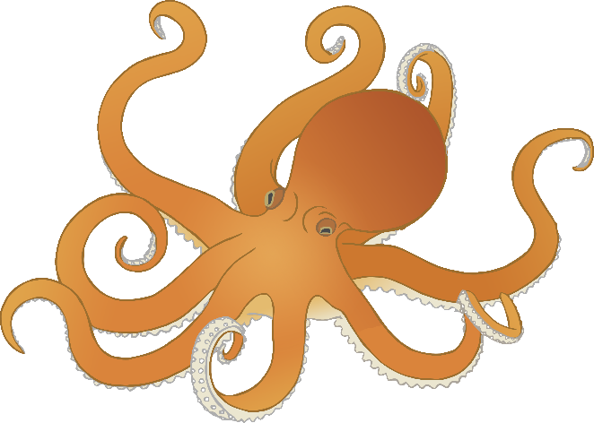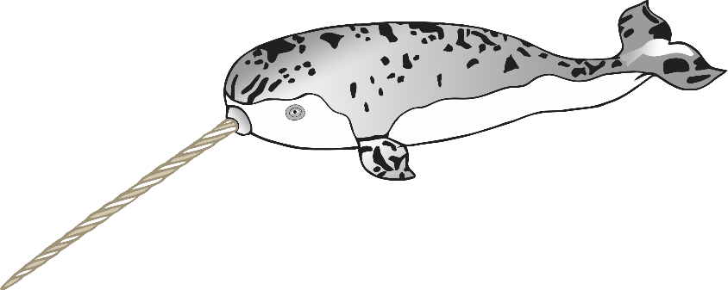

P

pig

**Q**

quail

R

rabbit

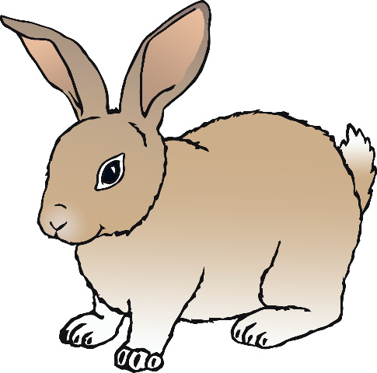

S

squirrel

T

tiger

U

umbrella bird

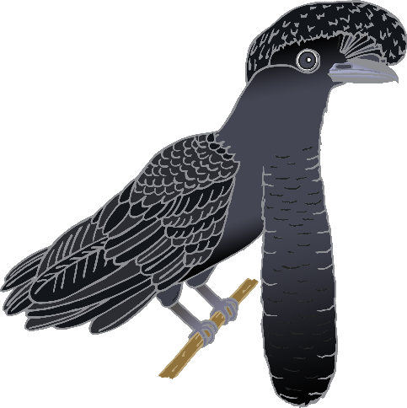

V

vulture

W

wolf

X

fox

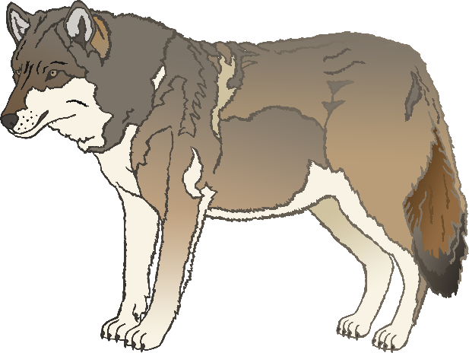

Y

yak

Z

zebra