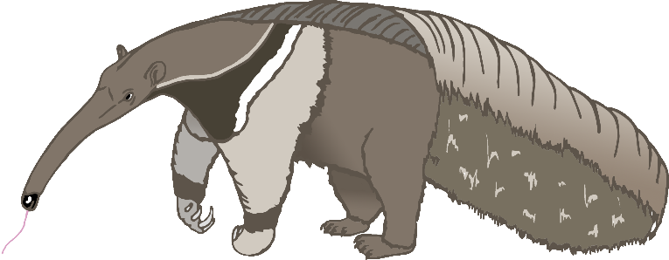

a

anteater

b

bat

c

cow

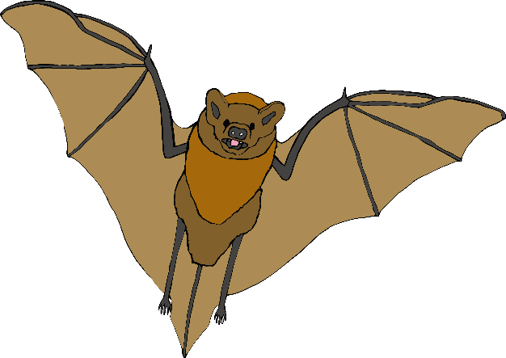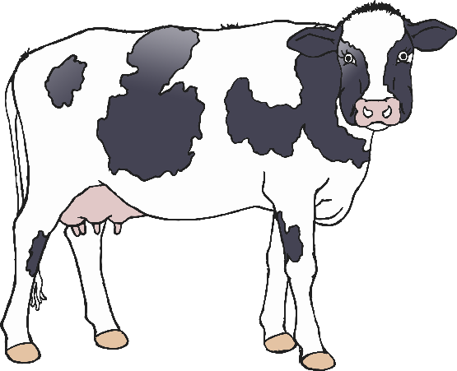

d

dog

e

elephant

f

frog

g

goat

h

horse

i

iguana

j

jellyfish

k

kangaroo

l

lion

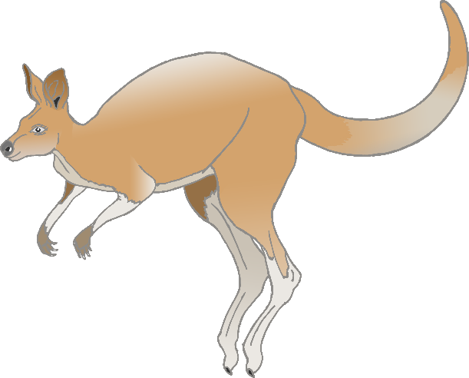

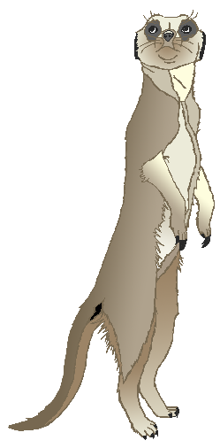

m

meerkat

n

narwhal

o

octopus

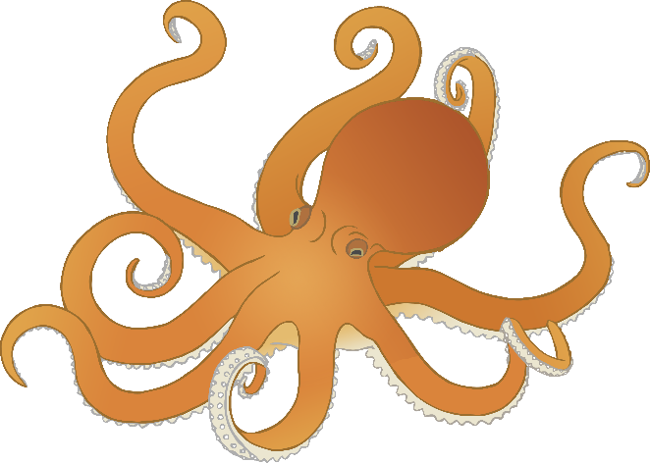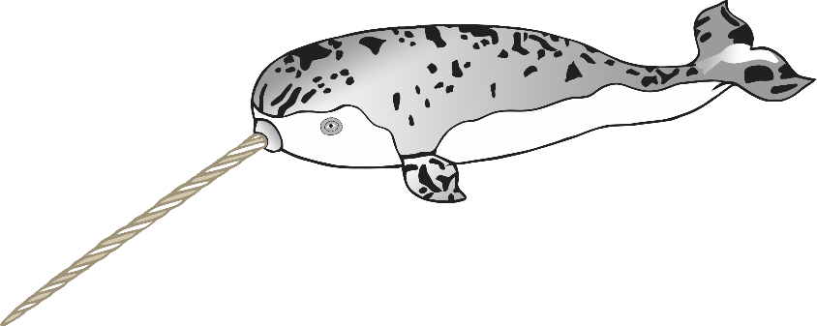

p

pig

q

quail

r

rabbit

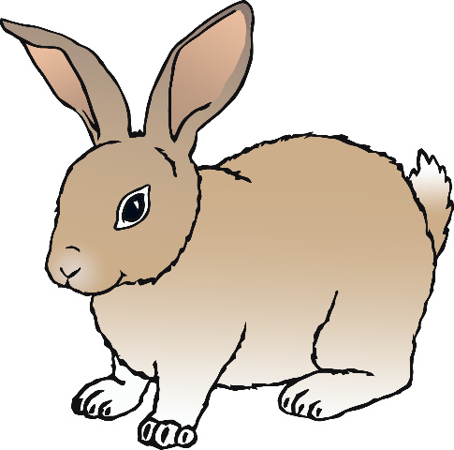

s

squirrel

t

tiger

u

umbrella bird

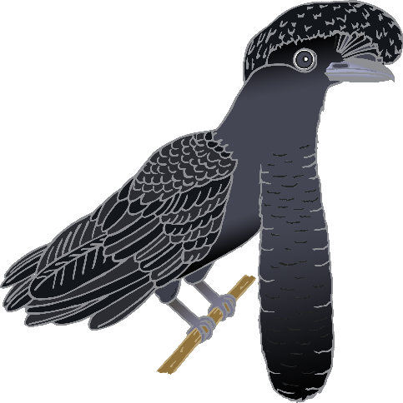

v

vulture

w

wolf

x

fox

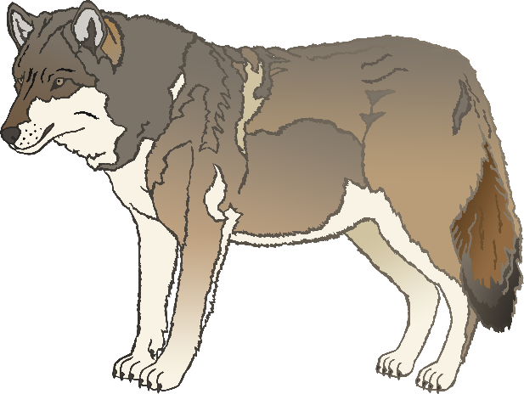

y

yak

z

zebra