**Plants need…**

© 2022 Little Owls Resources

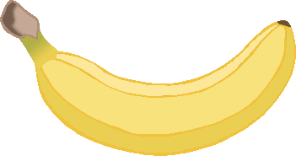



soil

water

sunlight

Carbon dioxide