**Plants need…**

© 2022 Little Owls Resources

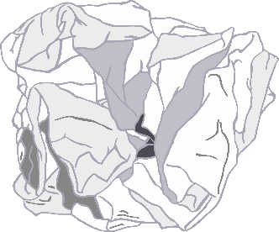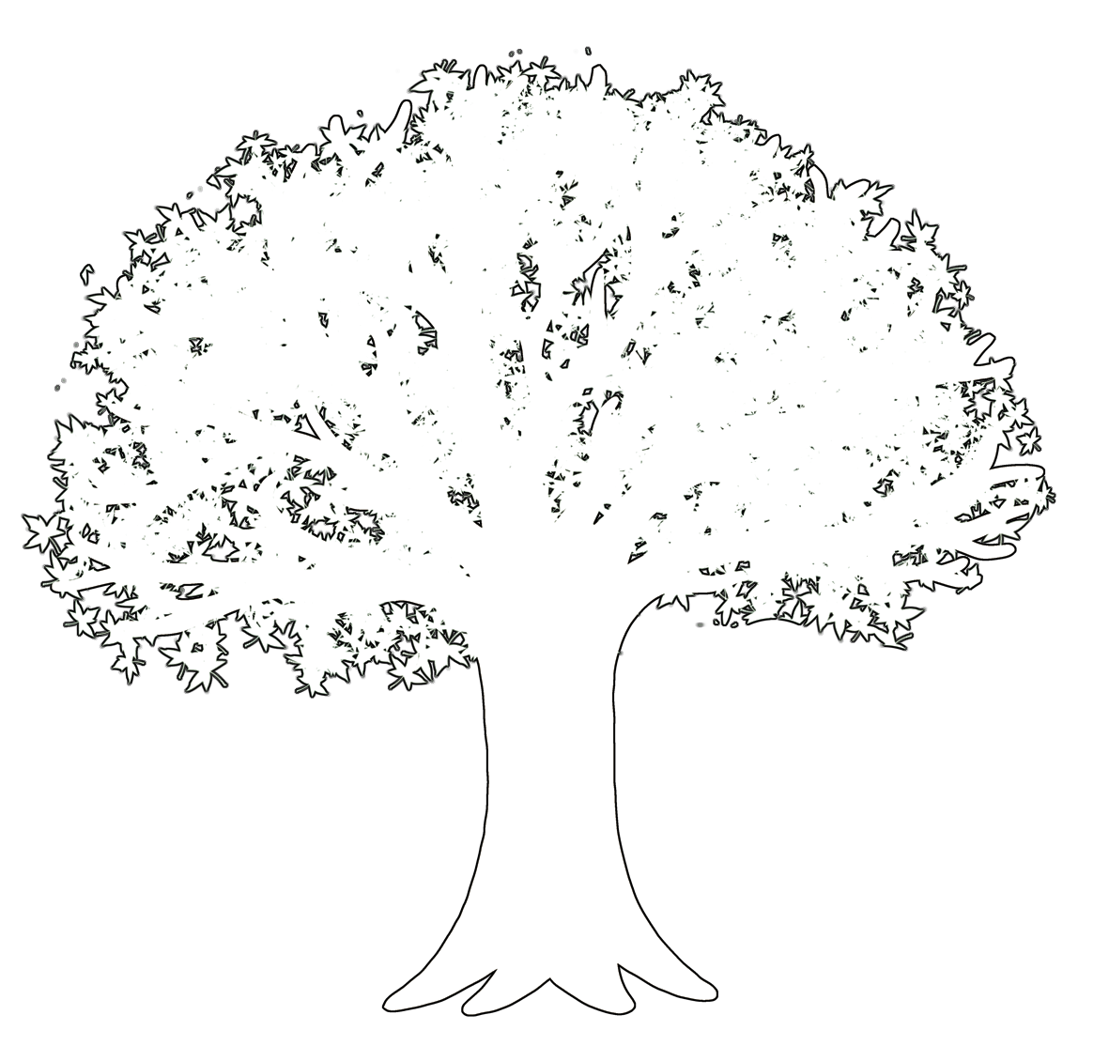



**soil**

**water**

**sunlight**

**Carbon dioxide**