**All About Me**

© 2022 Little Owls Resources

run

ACTION cards

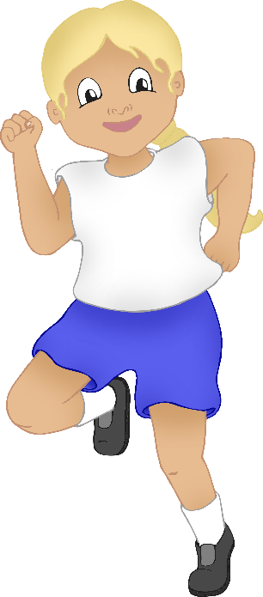

**All About Me**

© 2022 Little Owls Resources

**w**alk

ACTION cards

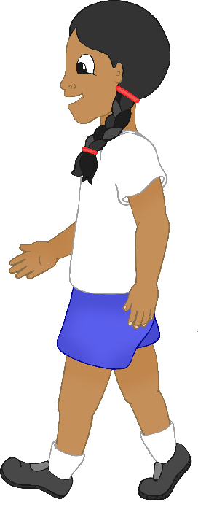

**All About Me**

© 2022 Little Owls Resources

brush

(teeth)

ACTION cards

**All About Me**

© 2022 Little Owls Resources

climb

ACTION cards

**All About Me**

© 2022 Little Owls Resources

get dressed

ACTION cards

**All About Me**

© 2022 Little Owls Resources

build

ACTION cards

**All About Me**

© 2022 Little Owls Resources

**w**ash (hands)

ACTION cards

**All About Me**

© 2022 Little Owls Resources

sit

ACTION cards

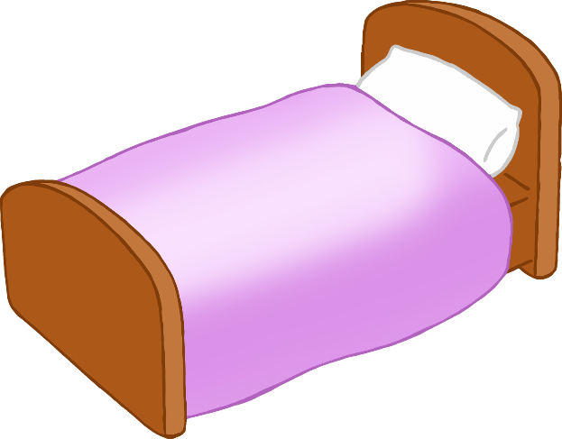

Z

Z

Z

Z

**All About Me**

© 2022 Little Owls Resources

stand

ACTION cards

**All About Me**

© 2022 Little Owls Resources

sleep

ACTION cards

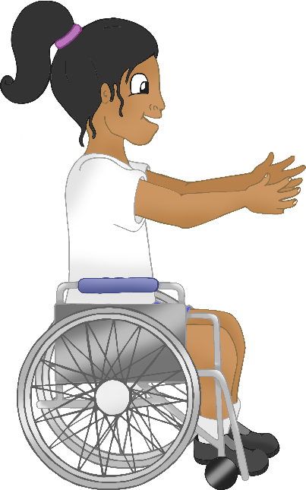

**All About Me**

© 2022 Little Owls Resources

thro**w**

ACTION cards

**All About Me**

© 2022 Little Owls Resources

catch

ACTION cards

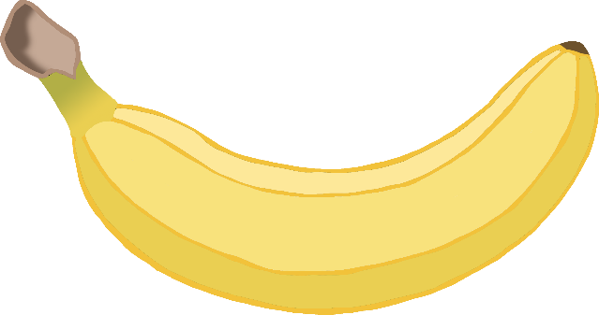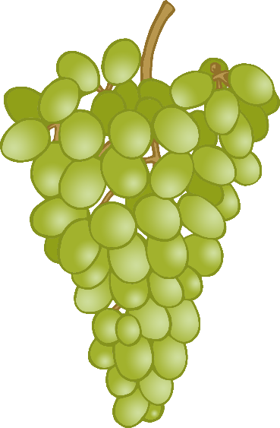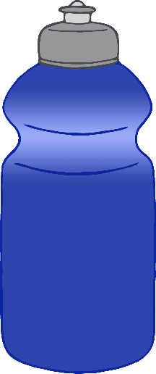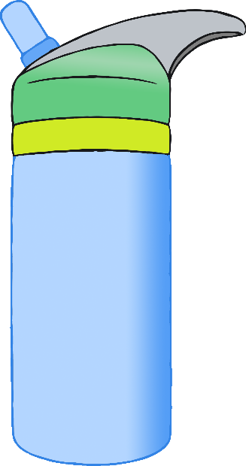

**All About Me**

© 2022 Little Owls Resources

eat

ACTION cards

**All About Me**

© 2022 Little Owls Resources

drink

ACTION cards

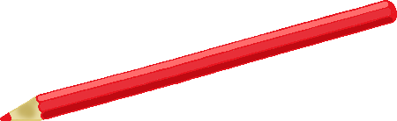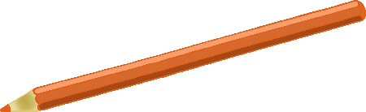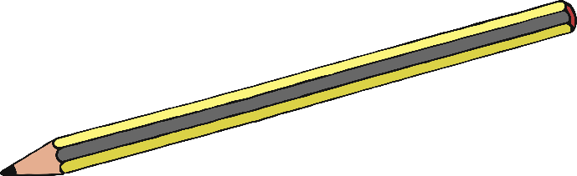

**All About Me**

© 2022 Little Owls Resources

dra**w**

ACTION cards

**All About Me**

© 2022 Little Owls Resources

**w**rite

ACTION cards

**GO**

**All About Me**

© 2022 Little Owls Resources

stop

ACTION cards

**All About Me**

© 2022 Little Owls Resources

go

ACTION cards

**All About Me**

© 2022 Little Owls Resources

sing

ACTION cards

**All About Me**

© 2022 Little Owls Resources

brush

(hair)

ACTION cards

**All About Me**

© 2022 Little Owls Resources

see

ACTION cards

**All About Me**

© 2022 Little Owls Resources

look

ACTION cards

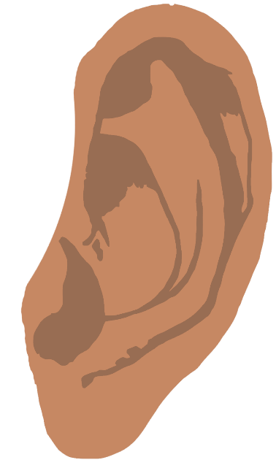

**All About Me**

© 2022 Little Owls Resources

hear

ACTION cards

**All About Me**

© 2022 Little Owls Resources

listen

ACTION cards

**All About Me**

© 2022 Little Owls Resources

feel

ACTION cards

**All About Me**

© 2022 Little Owls Resources

touch

ACTION cards

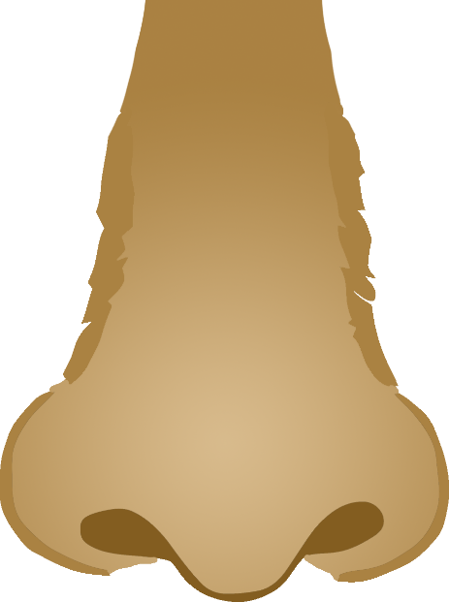

**All About Me**

© 2022 Little Owls Resources

smell

ACTION cards

**All About Me**

© 2022 Little Owls Resources

taste

ACTION cards

**All About Me**

© 2022 Little Owls Resources

jump

ACTION cards

**All About Me**

© 2022 Little Owls Resources

cra**w**l

ACTION cards

**All About Me**

© 2022 Little Owls Resources

kick

ACTION cards

**All About Me**

© 2022 Little Owls Resources

hop

ACTION cards

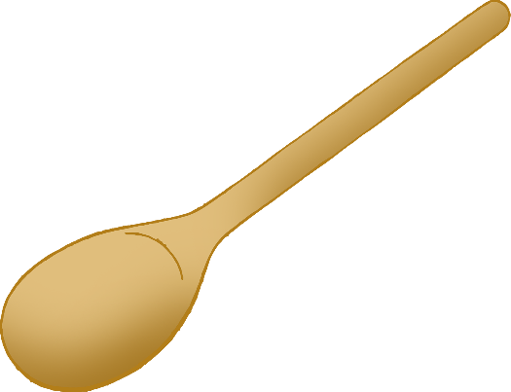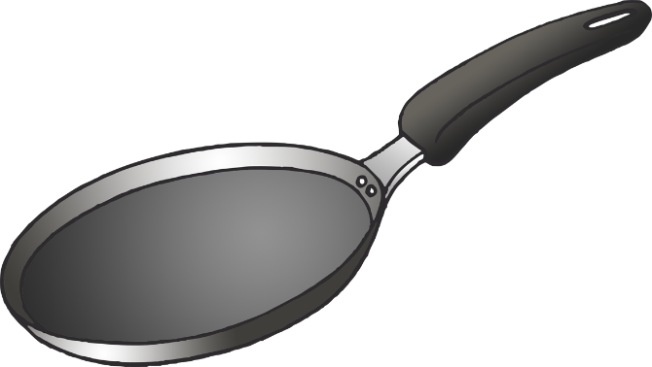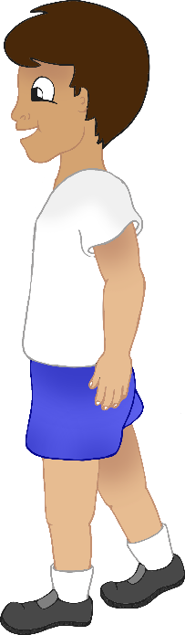

**All About Me**

© 2022 Little Owls Resources

cook

ACTION cards

**All About Me**

© 2022 Little Owls Resources

think

ACTION cards

**All About Me**

© 2022 Little Owls Resources

talk

ACTION cards

**All About Me**

© 2022 Little Owls Resources

line up

ACTION cards