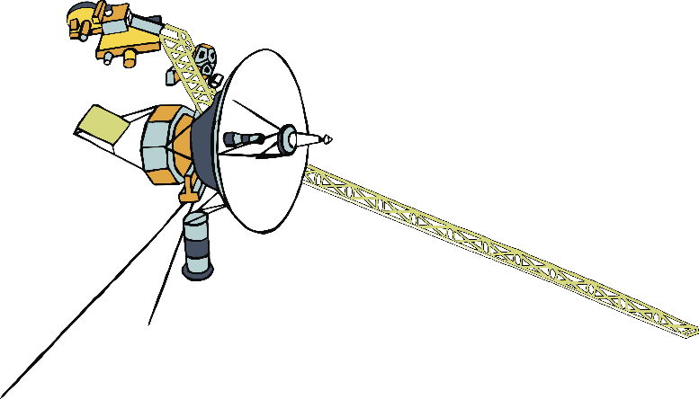

**INCREDIBLE**

**NEWS!**

© 2021 Little Owls Resources

**The Voyager Probe has contacted alien life!**

**Here comes the picture of the alien!**