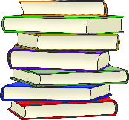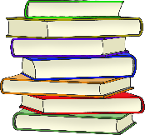

**A book I love is…**

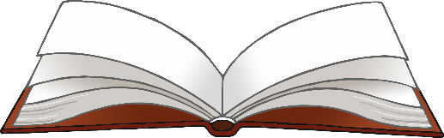

© 2023 Little Owls Resources

© 2023 Little Owls Resources

________­­­­­­­­­­­­­­­­­­­______________________

______________________________

______________________________

______________________________

­______________________________

______________________________

­______________________________

______________________________



**A book I love is…**



**A book I love is…**



© 2023 Little Owls Resources

**________­­­­­­­­­­­­­­­­­­­______________________**

**______________________________**

**______________________________**

**______________________________**

**­______________________________**

**______________________________**

**­______________________________**



**A book I love is…**



© 2023 Little Owls Resources

**________________________________________________________________________________________________________________________________________________________________________________________________________________________________________________________________________________________________________________________________________________________________________________**