1, 2, 3, 4, 5…

Once I caught a fish alive

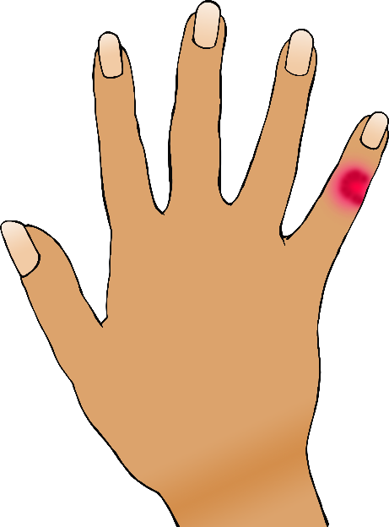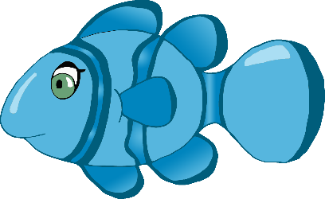

One, two, three, four, five

Once I caught a fish alive,

Six, seven, eight, nine, ten,

Then I let it go again.

Why did you let it go?

Because it bit my finger so.

Which finger did it bite?

This little finger on my right.

© 2019 Little Owls Resources

1, 2, 3, 4, 5…

Once I caught a fish alive



One, two, three, four, five

Once I caught a fish alive,

Six, seven, eight, nine, ten,

Then I let it go again.

Why did you let it go?

Because it bit my finger so.

Which finger did it bite?

This little finger on my right.

© 2019 Little Owls Resources

1, 2, 3, 4, 5…

Once I caught a fish alive



One, two, three, four, five

Once I caught a fish alive,

Six, seven, eight, nine, ten,

Then I let it go again.

Why did you let it go?

Because it bit my finger so.

Which finger did it bite?

This little finger on my right.

© 2019 Little Owls Resources

1, 2, 3, 4, 5…

Once I caught a fish alive



One, two, three, four, five

Once I caught a fish alive,

Six, seven, eight, nine, ten,

Then I let it go again.

Why did you let it go?

Because it bit my finger so.

Which finger did it bite?

This little finger on my right.

© 2019 Little Owls Resources