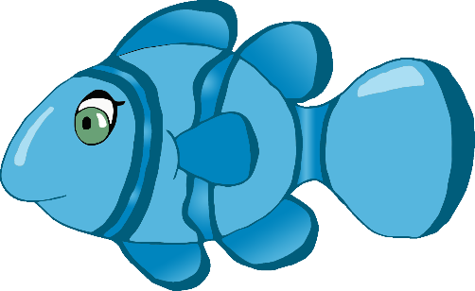

One, two, three, four, five

Once I caught a fish alive,

www.littleowls-premium.com © 2019 Little Owls Resources

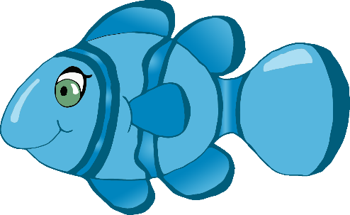

Six, seven, eight, nine, ten,

Then I let it go again.

www.littleowls-premium.com © 2019 Little Owls Resources

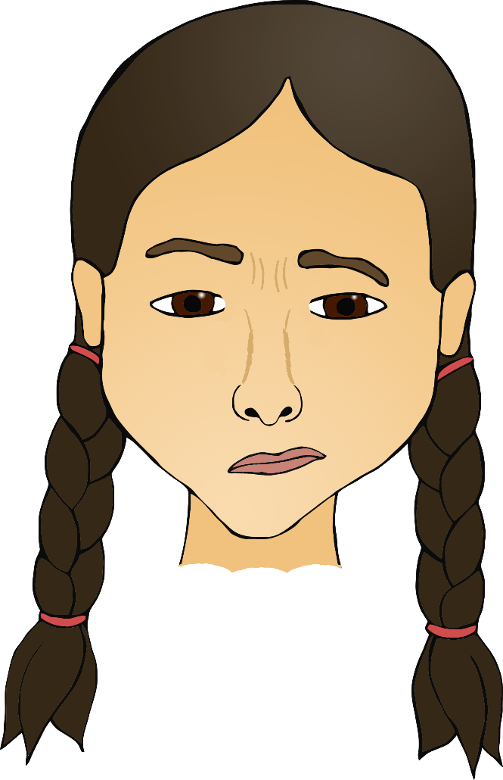

**?**

**?**

**?**

Why did you let it go?

Because it bit my finger so.

www.littleowls-premium.com © 2019 Little Owls Resources

Which finger did it bite?

This little finger on my right.

www.littleowls-premium.com © 2019 Little Owls Resources