1,2,3,4,5… Once I caught a fish alive

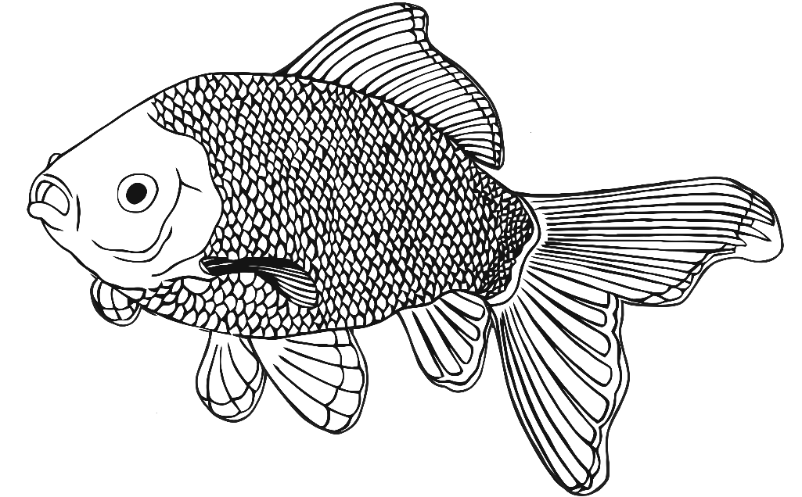

**Why did you let it go?**

**Because it bit my finger so.**

**Which finger did it bite?**

**This little finger on my right.**

© 2022 Little Owls Resources

**One, two, three, four, five**

**Once I caught a fish alive,**

**Six, seven, eight, nine, ten,**

**Then I let it go again.**

1,2,3,4,5… Once I caught a fish alive

© 2022 Little Owls Resources

**Why did you let it go?**

**Because it bit my finger so.**

**Which finger did it bite?**

**This little finger on my right.**

**One, two, three, four, five**

**Once I caught a fish alive,**

**Six, seven, eight, nine, ten,**

**Then I let it go again.**

1,2,3,4,5… Once I caught a fish alive