© 2022 Little Owls Resources

1,2,3,4,5, once I caught a fish alive.

1,2,3,4,5… Fish Alive

Illustration Activity

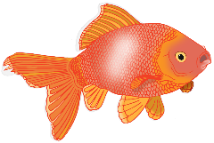

© 2022 Little Owls Resources

6,7,8,9,10, then I let him go again.

1,2,3,4,5… Fish Alive

Illustration Activity



© 2022 Little Owls Resources

Why did you let it go? Because it bit my finger so.

1,2,3,4,5… Fish Alive

Illustration Activity



© 2022 Little Owls Resources

Which finger did it bite? This little finger on my right.

1,2,3,4,5… Fish Alive

Illustration Activity

