**100 Square - Summer**

|  |  |  |  |  |  |  |  |  |  |
| --- | --- | --- | --- | --- | --- | --- | --- | --- | --- |
| **1** | **2** | **3** | **4** | **5** | **6** | **7** | **8** | **9** | **10** |
| **11** | **12** | **13** | **14** | **15** | **16** | **17** | **18** | **19** | **20** |
| **21** | **22** | **23** | **24** | **25** | **26** | **27** | **28** | **29** | **30** |
| **31** | **32** | **33** | **34** | **35** | **36** | **37** | **38** | **39** | **40** |
| **41** | **42** | **43** | **44** | **45** | **46** | **47** | **48** | **49** | **50** |
| **51** | **52** | **53** | **54** | **55** | **56** | **57** | **58** | **59** | **60** |
| **61** | **62** | **63** | **64** | **65** | **66** | **67** | **68** | **69** | **70** |
| **71** | **72** | **73** | **74** | **75** | **76** | **77** | **78** | **79** | **80** |
| **81** | **82** | **83** | **84** | **85** | **86** | **87** | **88** | **89** | **90** |
| **91** | **92** | **93** | **94** | **95** | **96** | **97** | **98** | **99** | **100** |

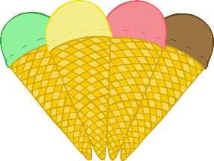

© 2021 Little Owls Resources