1

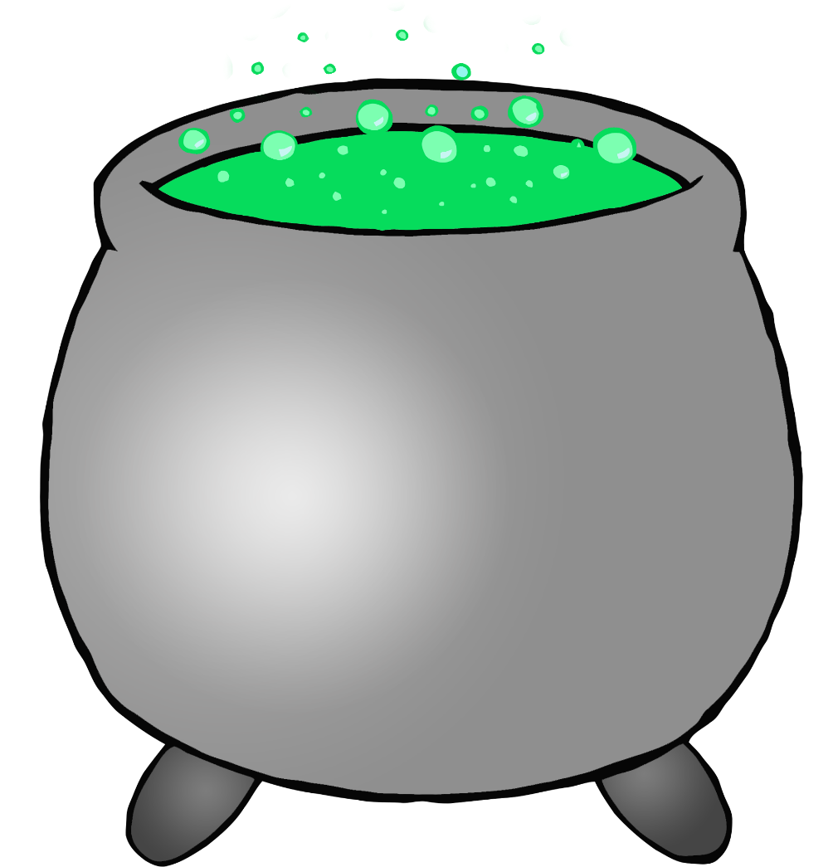

2

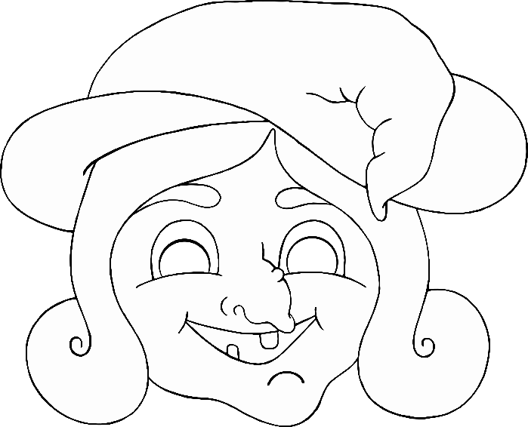3



4

5

6

7

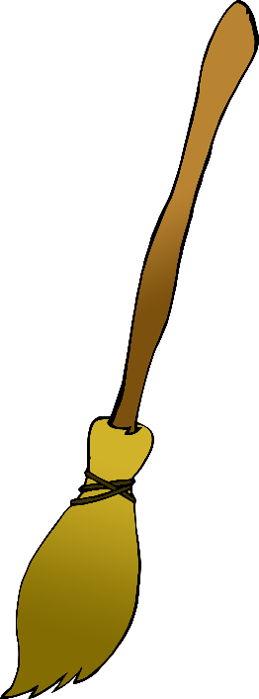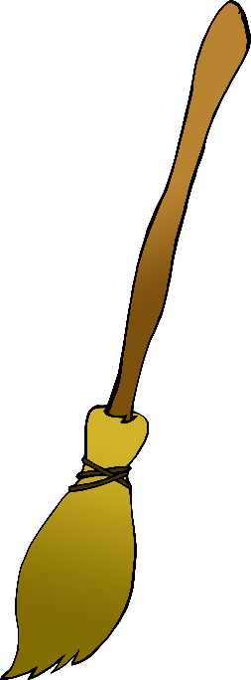8

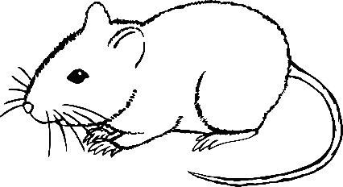9

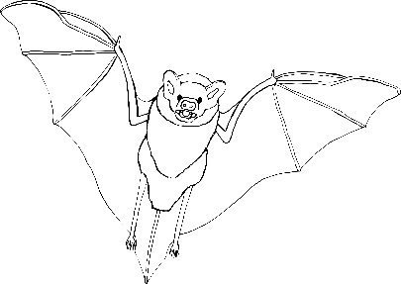10

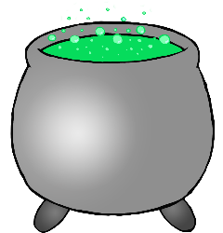11

12

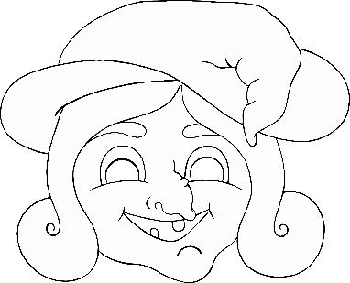13

14

15

16

17

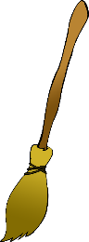18

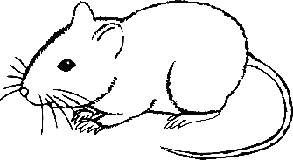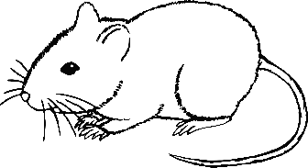19

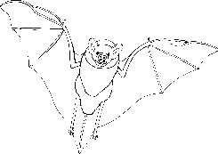20