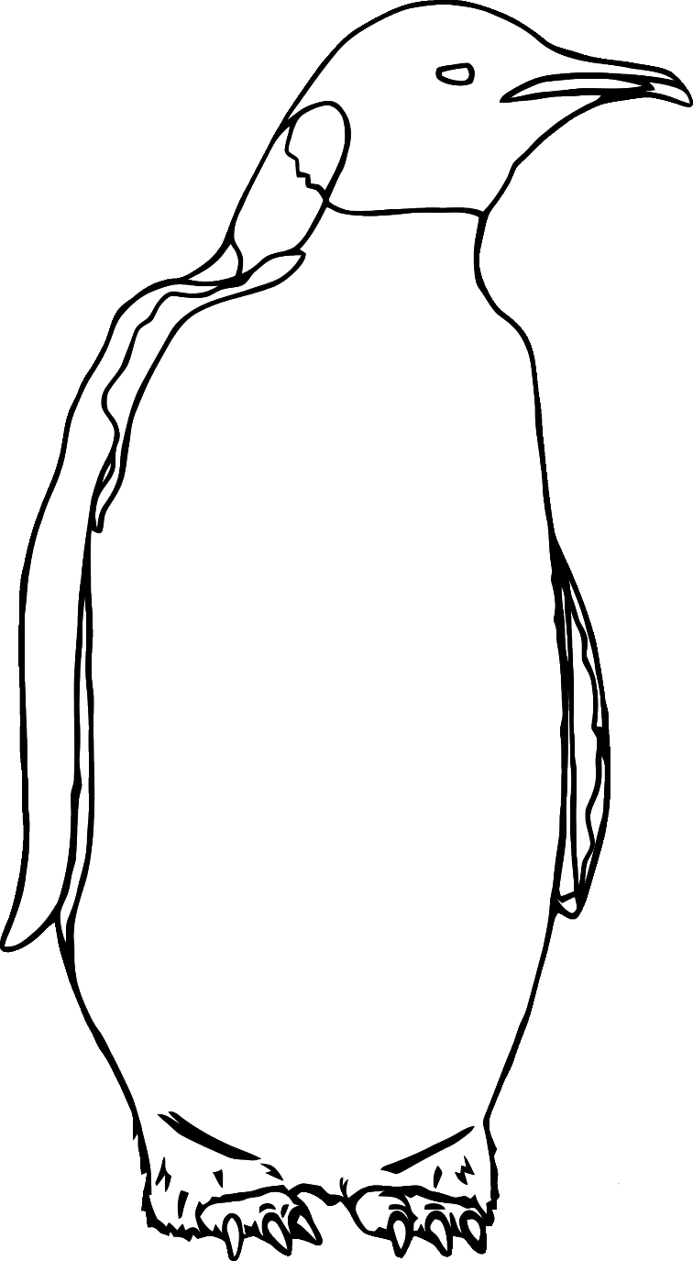1

2

3

4

5

6

7

8

9

10

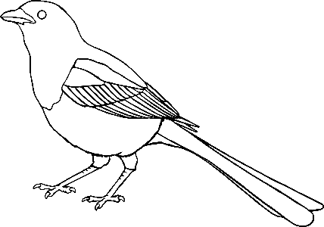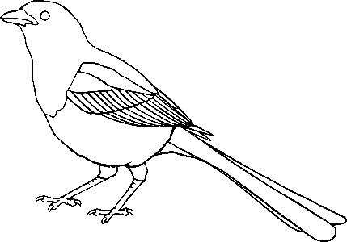11



12

13

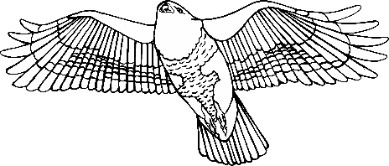14

15

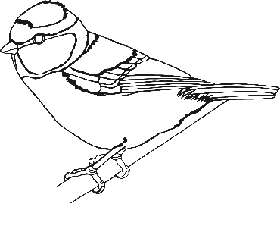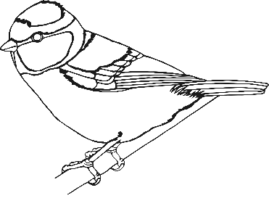16



17

18

19

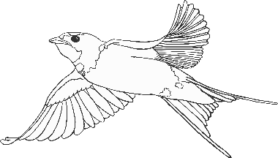20

