1

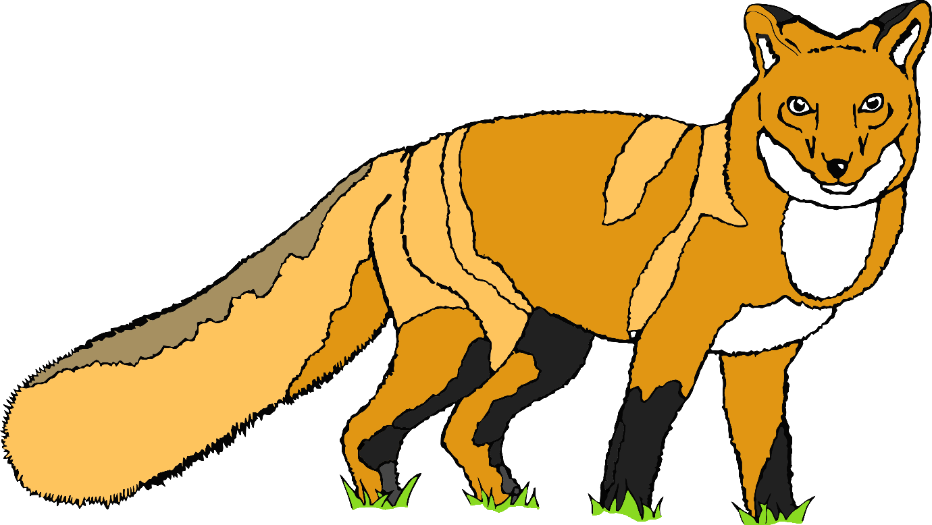

2

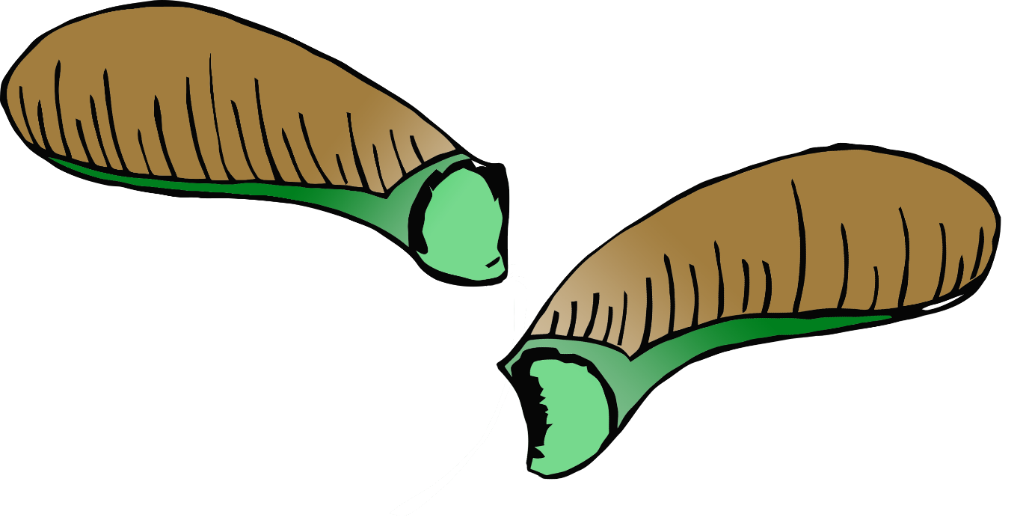

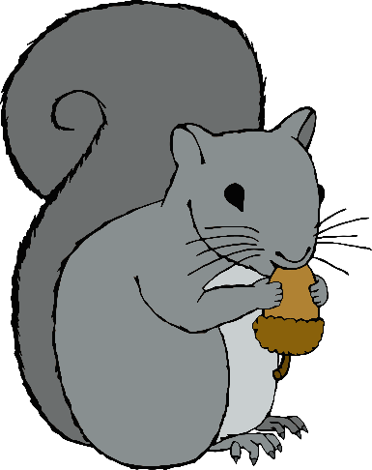3

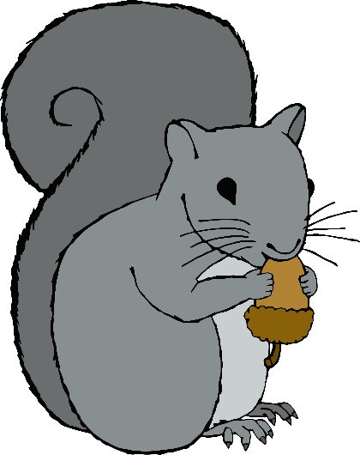

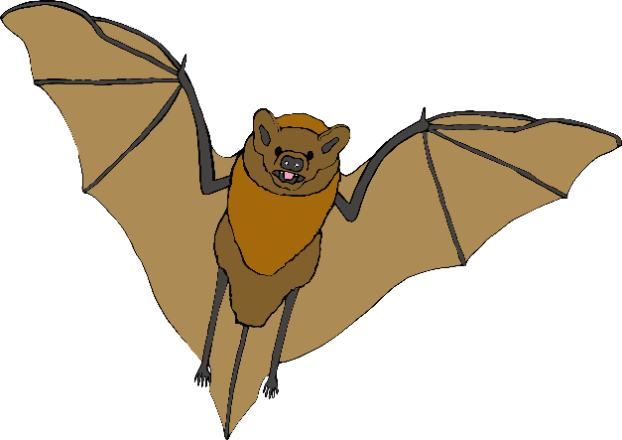4



5

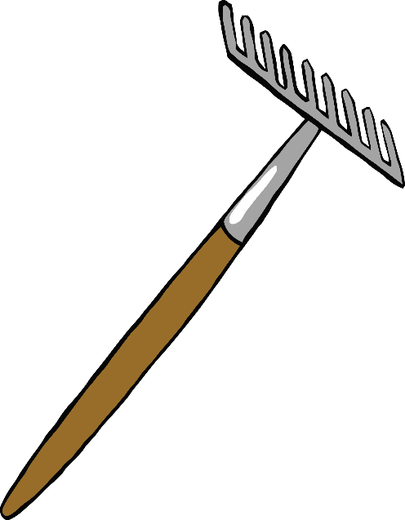6

7

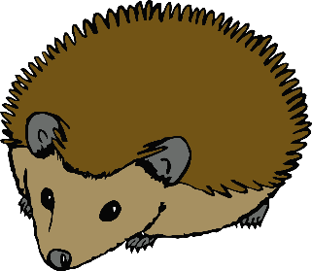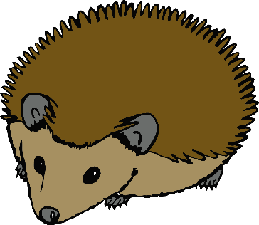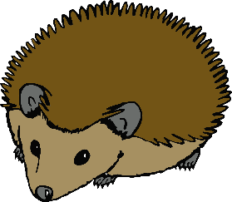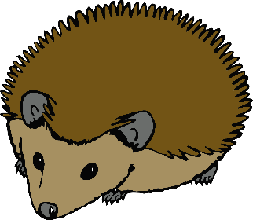

8

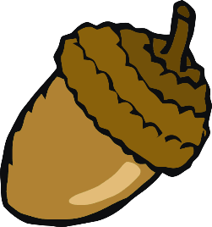9

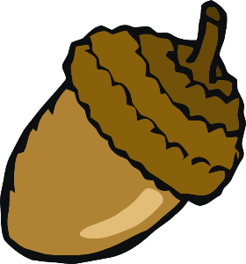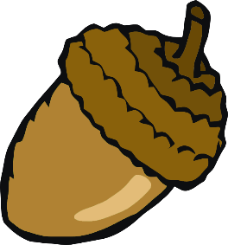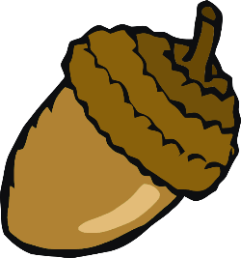

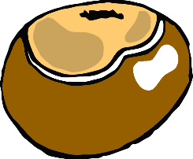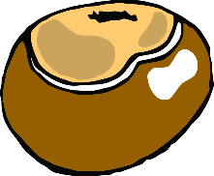10

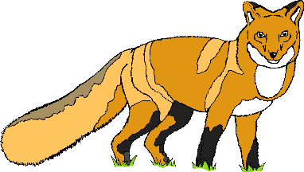11



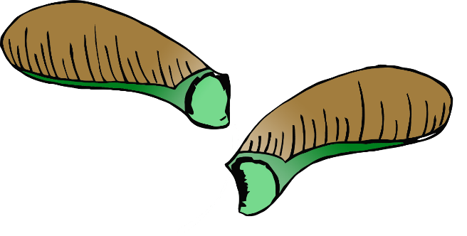12



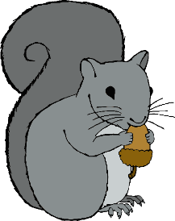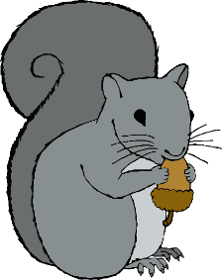13



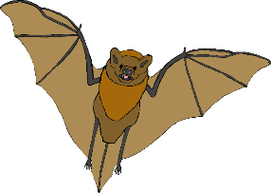14

15



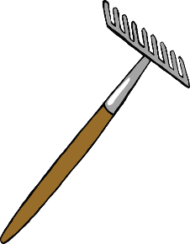16



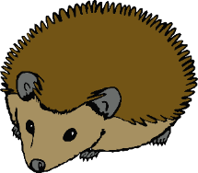17



18

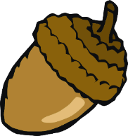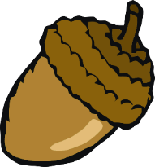19



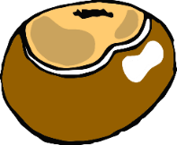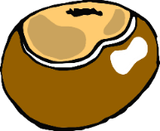20

