0

1

2

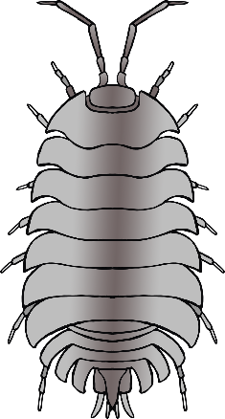3



4

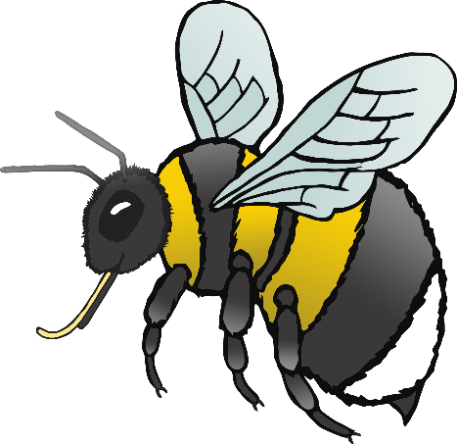5

6

7

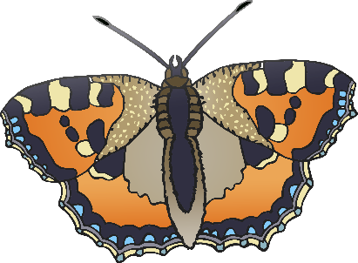8

9

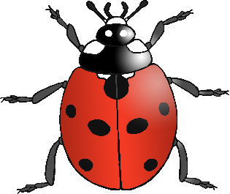10



11

12

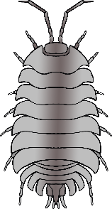13



14

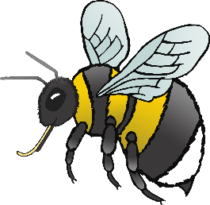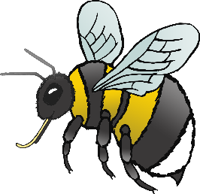15



16

17

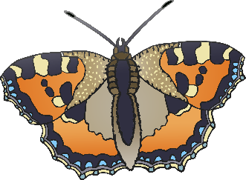18



19

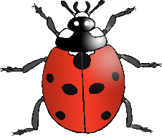20

