0



1

2

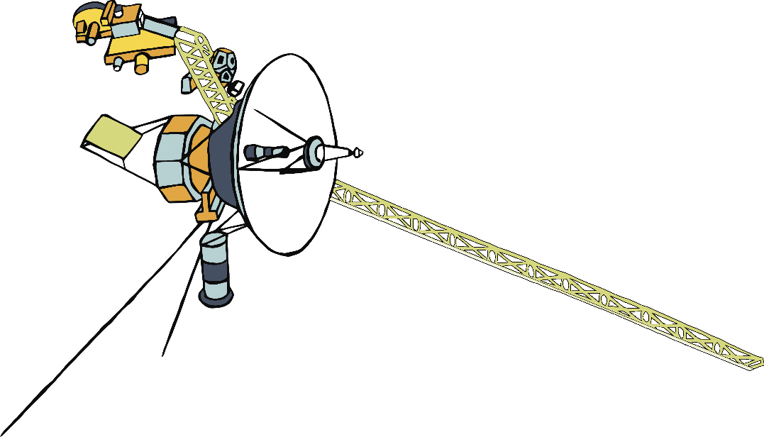

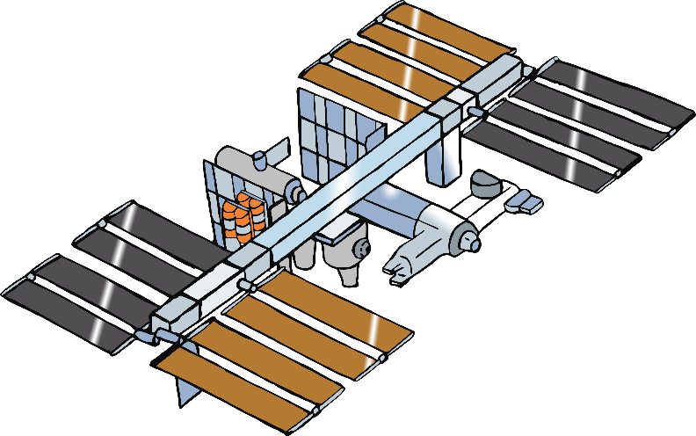

3

4



5

6

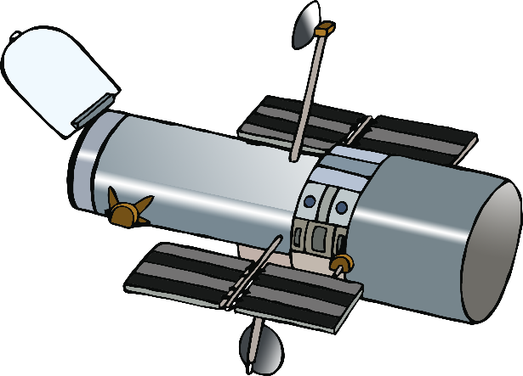

7



8

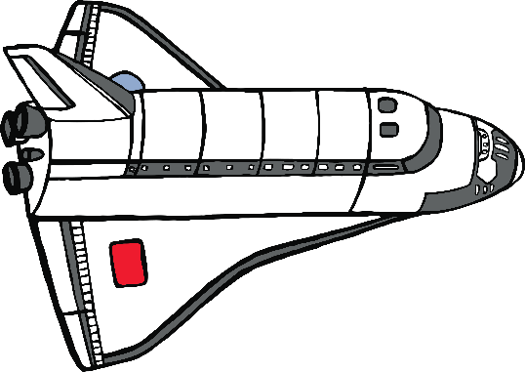

9

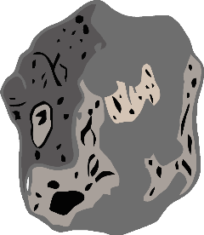

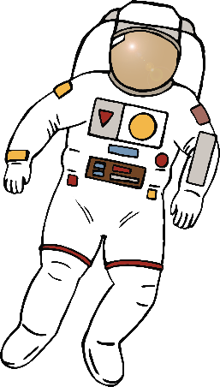

10