0

sero

(s-air-o)

zero

1

un

(een)

one

2

dau

(die)

two

3

tri

(tree)

three

4

pedwar

(ped-warr)

four

5

pump

(pimp)

five

6

chwech

(cch-wair-cch) ✱

six

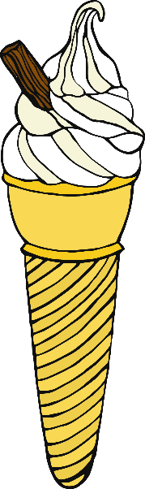7

✱ The sound ‘cch’ has no common English equivalent. It is made in the back of the throat as in the Scots word lo**ch**.

saith

(s-eye-th)

seven

8

wyth

(weeth)

eight

9

naw

(now)

nine

10

deg

(dayg)

ten

