0

English/Ukrainian

© 2022 Little Owls Resources

нуль

(nool)

zero

1

один

(oh-din)

one

English/Ukrainian

© 2022 Little Owls Resources

2

два

(dva)

two

English/Ukrainian

© 2022 Little Owls Resources

3

три

(tree)

three

English/Ukrainian

© 2022 Little Owls Resources

4

чотири

(cho-teer-ee)

four

English/Ukrainian

© 2022 Little Owls Resources

5

п'ять

(pee-yut)

five

English/Ukrainian

© 2022 Little Owls Resources

6

шість

(sheest)

six

English/Ukrainian

© 2022 Little Owls Resources

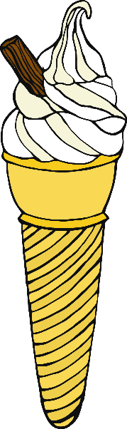7

cім

(sim)

seven

English/Ukrainian

© 2022 Little Owls Resources

8

вісім

(vee-sim)

eight

English/Ukrainian

© 2022 Little Owls Resources

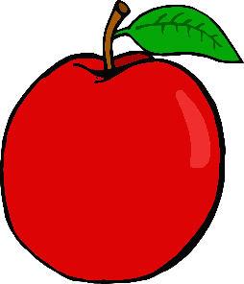9

дев'ять

(dev-yet)

nine

English/Ukrainian

© 2022 Little Owls Resources

10

Десять

(deh-sit)

ten

English/Ukrainian

© 2022 Little Owls Resources

