0

English/Russian

© 2022 Little Owls Resources

нуль

(nool)

zero

1

English/Russian

© 2022 Little Owls Resources

один

(adeen)

one

2

два

(dva)

two

English/Russian

© 2022 Little Owls Resources

3

три

(tree)

three

English/Russian

© 2022 Little Owls Resources

4

четыре

(chi-teer-ya)

four

English/Russian

© 2022 Little Owls Resources

5

пять

(pyat)

five

English/Russian

© 2022 Little Owls Resources

6

шесть

(shest)

six

English/Russian

© 2022 Little Owls Resources

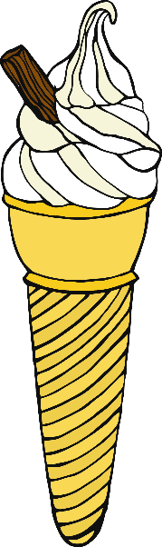7

семь

(sim)

seven

English/Russian

© 2022 Little Owls Resources

8

восемь

(vor-sim)

eight

English/Russian

© 2022 Little Owls Resources

9

девять

(d-air-vit)

nine

English/Russian

© 2022 Little Owls Resources

10

десять

(day-sit)

ten

English/Russian

© 2022 Little Owls Resources

