0

English/Punjabi

© 2022 Little Owls Resources

ਸਿਫਰ

(sifar)

zero

1

ਇੱਕ

(ikk)

one

English/Punjabi

© 2022 Little Owls Resources

2

ਦੋ

(do)

two

English/Punjabi

© 2022 Little Owls Resources

3

ਤਿੱਨ

(tinn)

three

English/Punjabi

© 2022 Little Owls Resources

4

ਚਾਰ

(char)

four

English/Punjabi

© 2022 Little Owls Resources

5

ਪੰਜ

(panj)

five

English/Punjabi

© 2022 Little Owls Resources

6

ਛੇ

(che)

six

English/Punjabi

© 2022 Little Owls Resources

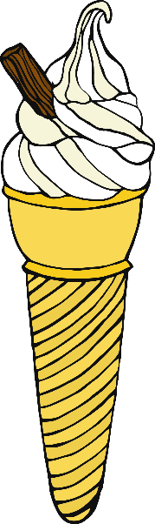7

ਸੱਤ

(satt)

seven

English/Punjabi

© 2022 Little Owls Resources

8

ਅੱਠ

(ath)

eight

English/Punjabi

© 2022 Little Owls Resources

9

ਨੌਂ

(nau)

nine

English/Punjabi

© 2022 Little Owls Resources

10

ਦਸ

(das)

ten

English/Punjabi

© 2022 Little Owls Resources

