0

English/Arabic

© 2022 Little Owls Resources

صفر

(sifr)

zero

1

واحد

(waahid)

one

English/Arabic

© 2022 Little Owls Resources

2

إثنان

(ithnaan)

two

English/Arabic

© 2022 Little Owls Resources

3

ثلاثة

(thalaatha)

three

English/Arabic

© 2022 Little Owls Resources

4

اربعة

(arba’a)

four

English/Arabic

© 2022 Little Owls Resources

5

خمسة

(khamsa)

five

English/Arabic

© 2022 Little Owls Resources

6

ستة

(sitta)

six

English/Arabic

© 2022 Little Owls Resources

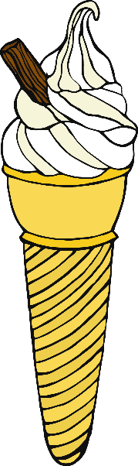7

سبعة

(sab’a)

seven

English/Arabic

© 2022 Little Owls Resources

8

ثمانية

(thamaaniya)

eight

English/Arabic

© 2022 Little Owls Resources

9

تسعة

(tis’a)

nine

English/Arabic

© 2022 Little Owls Resources

10

عشرة

(‘ashara)

ten

English/Arabic

© 2022 Little Owls Resources

