0

1

2

3

4

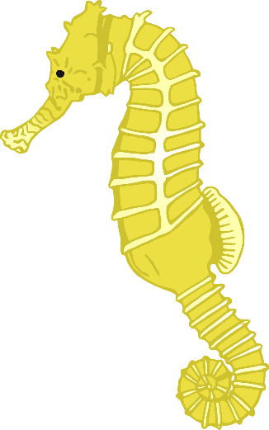5



6

7

8

9

10

